**Comparing Classifiers**

Contents

Business Objective 3

Notebook path: 4

Initial observations: 4

Descriptive Statistics: Key Observations 5

Data Handling: 5

Cleaned Dataset Summary 6

Key Findings from Visualizations 7

Numerical features vs Target 10

Categorical features vs Target 17

Correlation matrix: 21

Multivariate Analysis 23

Classifier Models 26

Baseline model: 26

KNN Classifier 26

Simple KNN 27

KNN fine-tuned 28

KNN fine-tuned with feature selection 29

KNN fine-tuned with feature selection and threshold tuning 30

KNN fine tuned with feature selection and class_weight=’balanced’ (MinMaxScaler) 31

Logistic Regression Classifier: 33

Simple Logistic Regression 35

Logistic Regression fine tuned 36

Logistic Regression fine tuned with feature selection 37

Logistic Regression fine tuned with feature selection and class_weight=’balanced’ 38

Logistic Regression fine tuned with feature selection and class_weight=’balanced’ (MinMaxScaler) 40

Decision Tree: 41

Simple Decision Tree 42

Decision Tree fine tuned 43

Decision Tree fine tuned with feature selection 46

Decision Tree fine tuned with feature selection and class_weight=’balanced’ 48

Decision Tree fine tuned with feature selection and class_weight= ’balanced’ (MinMaxScaler) 50

SVM Classifier 50

Simple SVM model 52

SVM model fine tuned 52

SVM model fine tuned with feature selection 53

SVM model fine tuned with feature selection and class_weight= ’balanced’ 55

SVM model fine tuned with feature selection and class_weight= ’balanced’ (MinMaxScaler) 55

Model comparison 58

Model comparison with undersampling 59

Summary of model comparison 60

Key Business Findings 62

Next Steps and Recommendations: 63

# Business Objective

The primary goal is to predict whether a client will subscribe to a term deposit (the target variable, **y**). By accurately forecasting client behavior, the bank can:

* **Optimize Campaigns:** Focus resources on clients most likely to convert, thereby reducing unnecessary costs.
* **Improve Efficiency:** Tailor follow-up strategies based on predictive insights, ensuring that contacts are made at the right time and with the right messaging.
* **Enhance Customer Targeting:** Identify key customer segments that are more receptive to the product, allowing for more personalized marketing approaches.

**Key Challenges**

* **Imbalanced Classes:** Typically, a relatively small fraction of clients subscribe to the term deposit. This class imbalance can affect model performance and requires special attention (e.g., through resampling or cost-sensitive techniques).
* **Multiple Contacts:** Since multiple calls may be needed before a client decides, understanding the temporal dynamics and call frequency can be crucial for model improvement.
* **Data Complexity:** The dataset includes a mix of demographic, social, and economic indicators, which can interact in complex ways to influence a client's decision.

**Business Value**

Developing a robust predictive model can help the bank:

* **Reduce Marketing Costs:** By targeting only the most promising leads, the bank can minimize the cost per acquisition.
* **Increase Conversion Rates:** Better targeting and timely interventions can lead to higher subscription rates.
* **Inform Strategy:** Insights from the model can guide broader marketing strategies, including message personalization and optimal contact frequency.

**Recommendation for This Scenario:**  
Given that the bank’s objective is to maximize the conversion of clients to term deposit subscribers and assuming that the cost of a phone call is relatively low compared to the potential revenue and customer lifetime value, the model should likely focus on reducing false negatives (i.e., increasing recall). This approach helps ensure that fewer potential subscribers are missed, even if it means contacting some clients who might ultimately not subscribe.

# Notebook path:

<https://github.com/shikhakala/Practical_Application_3/blob/main/Shikha_Practical_Application_3.ipynb>

# Initial observations:

**Dataset Size**

* **bank-additional-full.csv:**
  + **Rows:** 41,188 examples
  + **Columns:** 20 input features (plus the target variable “y”)

**Key Features**

The dataset comprises various types of features:

1. **Demographic Features:**
   * **Age:** Customer’s age.
   * **Job:** Type of job (e.g., admin, technician, management, etc.).
   * **Marital Status:** Whether the customer is single, married, or divorced.
   * **Education:** Educational background (e.g., primary, secondary, tertiary).
   * **Default:** Whether the customer has credit in default.
2. **Financial Information:**
   * **Housing Loan:** Indicates if the customer has a housing loan.
   * **Personal Loan:** Indicates if the customer has a personal loan.
3. **Campaign-Related Features:**
   * **Contact:** The type of communication used (generally telephone).
   * **Month/Day of Contact:** The month and day when the contact was made.
   * **Duration:** Duration of the last contact (in seconds).  
     *Note:* This is a key feature for predicting the outcome but is only available after the call.
   * **Campaign:** Number of contacts performed during this campaign.
   * **Pdays:** Number of days that passed after the client was last contacted from a previous campaign.
   * **Previous:** Number of contacts performed before this campaign.
   * **Poutcome:** Outcome of the previous marketing campaign (e.g., success, failure).
4. **Economic Indicators (primarily in bank-additional-full.csv):**
   * **Emp.var.rate:** Employment variation rate.
   * **Cons.price.idx:** Consumer price index.
   * **Cons.conf.idx:** Consumer confidence index.
   * **Euribor3m:** Euribor 3-month rate.
   * **Nr.employed:** Number of employees.

# Descriptive Statistics: Key Observations

1. **Data Composition**
   * **Total Records:** 33,565 after cleaning (originally 41,188).
   * **Features:** A mix of demographic (e.g., age, job), campaign-related (e.g., pdays, previous, campaign), and macro-economic indicators (e.g., euribor3m, emp_var_rate).
   * **Class Imbalance:** Approximately 10% of clients subscribe to a term deposit (the minority class), while ~90% do not.
2. **Major Predictors (Descriptive Clues)**
   * **Previous Contact:** Clients who were contacted before show significantly higher subscription rates than those contacted for the first time.
   * **Macro-economic Indicators:** Employment variation rate (emp_var_rate) and Euribor rates (euribor3m) correlate with subscription likelihood, suggesting economic context matters.
   * **Demographics:** Features like job and age have mild to moderate effects; for example, certain occupations (e.g., students, retirees) show higher subscription rates.
3. **Distribution & Correlations**
   * High Inter-correlation among macro-economic variables (emp_var_rate, euribor3m, nr_employed).
   * Campaign Variables (pdays, previous, campaign) exhibit weaker correlations but become more predictive when converted into binary indicators like previously_contacted.

# Data Handling:

1. Replace '.' with '_' in column names
2. Drop Duration column to avoid data leakage
3. 1784 duplicates dropped
4. Drop rows with 'unknown' values where % < 5, else keep as 'unknown'
5. Remove outliers from 'age', 'campaign', 'cons_conf_idx' then drop duplicates

**Feature Engineering:**

1. Create column previously_contacted

'previously_contacted' = ['pdays'] != 999) | ['previous'] > 0

1. Create column 'pdays_contacted'

['pdays_contacted'] = ['pdays'].apply(lambda x: 0 if x == 999 else 1)

1. Encode target variable (y) replace({'no': 0, 'yes': 1})
2. Column housing and loan - Mapping yes/no to 1/0
3. Mapping months to numbers
4. Mapping days of the week to numbers (assuming 'mon' to 'sun')

# Cleaned Dataset Summary

* *Data Size After Cleaning:*
  1. Total Records: **33,565**
  2. Total columns: **22**
* Missing values ‘unknown’ in default column.

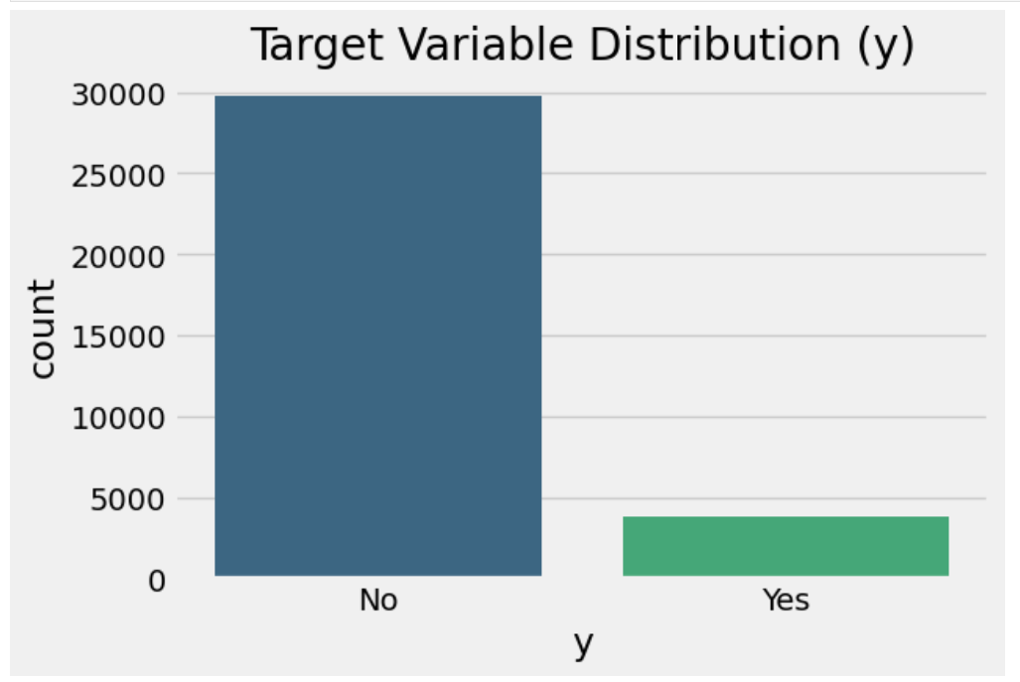

The bar chart shows a classic **class imbalance** in the target variable (yyy), where “No” (clients who did not subscribe) significantly outnumbers “Yes” (clients who did subscribe). This means:

* **Majority Class:** “No” – Most clients did not subscribe.
* **Minority Class:** “Yes” – Relatively fewer clients actually subscribed.

# Key Findings from Visualizations

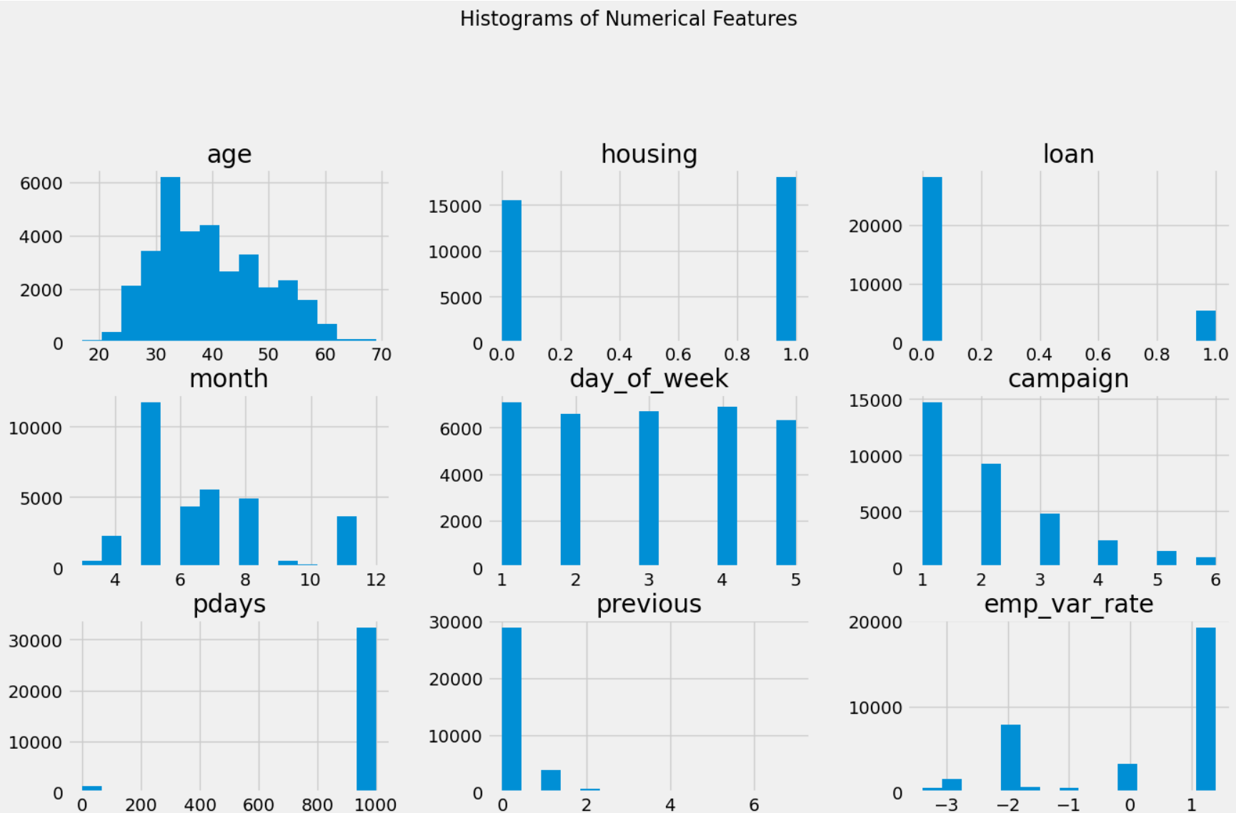

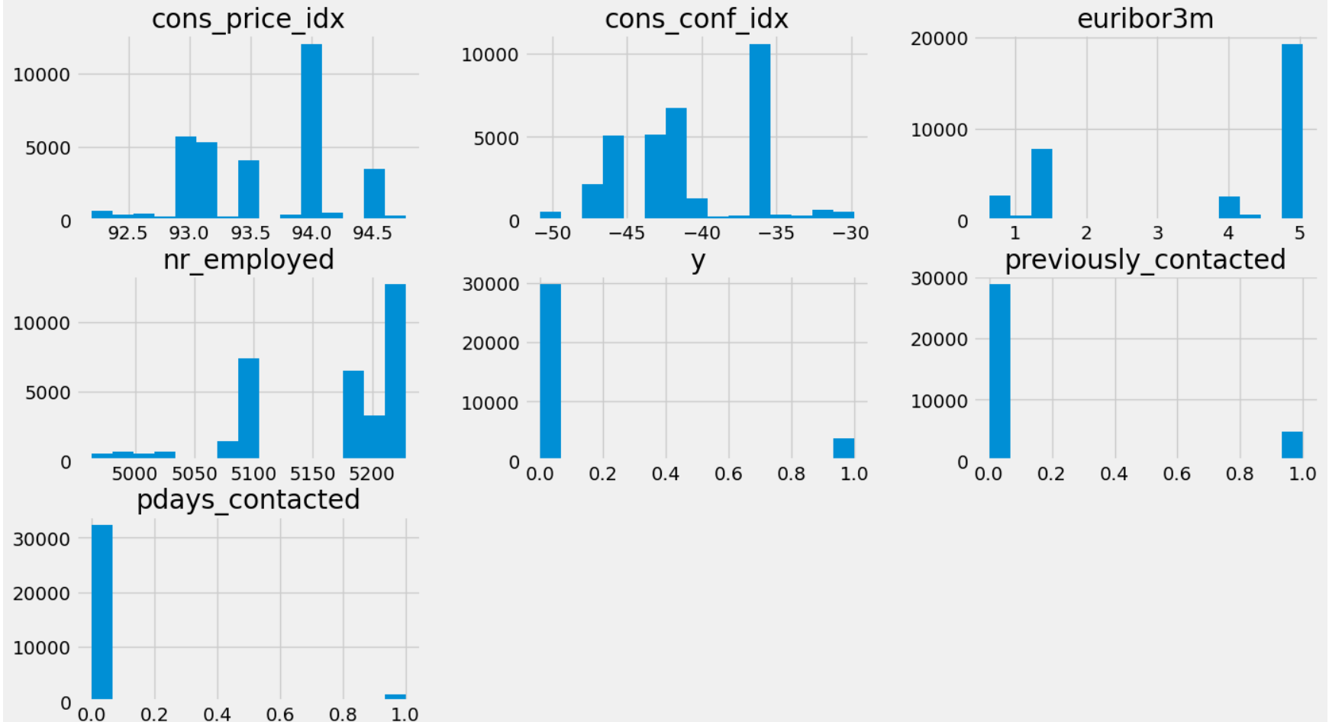

1. **Age**
   * **Distribution:** Concentrated mostly between the mid-20s and late 40s, with fewer older clients.
   * **Implication:** Suggests a younger to middle-aged client base is dominant. Age may or may not correlate strongly with subscription likelihood, so further analysis (e.g., age-grouped subscription rates) is worthwhile.
2. **Housing & Loan** (Binary: 1 = “Yes”, 0 = “No”)
   * **Housing:** A large share of clients appear to have a housing loan (housing=1).
   * **Loan:** Fewer clients have a personal loan (loan=1) compared to housing.
   * **Implication:** Clients with housing loans might have different financial behaviors than those without. Comparing subscription rates between these groups could be insightful.
3. **Month & Day_of_Week**
   * **Month (1–12):** Likely shows some seasonal pattern; some months may have more contacts than others.
   * **Day_of_Week (1–7):** Distribution can reveal if there are days with higher contact volume or better response rates.
4. **Campaign & Previous**
   * **Campaign:** Number of contacts in the current campaign is typically low (1 or 2), but a minority of clients receive many contacts.
   * **Previous:** Most clients have previous=0 (no prior contacts), with a small fraction having 1 or more.
   * **Implication:** Most individuals are new to the campaign, which can affect how we interpret the success of repeated contacts.
5. **Macro-Economic Variables**
   * **emp_var_rate, cons_price_idx, cons_conf_idx, euribor3m, nr_employed:**  
     Each has its own range and distribution. Strong correlations often exist among these indicators (as seen in the correlation heatmap).
   * **Implication:** These features may have predictive value if the bank’s marketing success is tied to broader economic conditions.
6. **Target (y)**
   * **Binary:** 0 = “No,” 1 = “Yes.”
   * The histogram confirms the class imbalance (many more “No” than “Yes”). This underscores the need for careful model evaluation and possibly imbalance-handling techniques (e.g., class weights, SMOTE).
7. **Previously Contacted** (Binary: 0 or 1)
   * Derived from pdays != 999 or previous > 0.
   * Many clients have previously_contacted=0, indicating they had not been contacted before.
   * **Implication:** Repeated contact may be a small subset, but it could have a distinct pattern in subscription rates.
8. **pdays_contacted** (Binary: 0 or 1)
   * **pdays_contacted=0** for most clients, indicating pdays=999 (no prior campaign contact).
   * A small fraction have pdays_contacted=1 (they were contacted in a previous campaign).
   * **Implication:** This confirms that the majority of the dataset consists of clients who are new to the bank’s campaigns.

**Overall Takeaways**

* **Class Imbalance:** Most clients do not subscribe, which is visible in the target variable (y).
* **Repeated Contacts Are Relatively Rare:** Both previous and pdays_contacted show that most clients are first-time contacts.
* **Housing Loans Are Common; Personal Loans Less So:** Could signal different financial profiles within the customer base.
* **Age Skews Younger to Middle-Aged:** Potentially important for marketing strategies.

# Numerical features vs Target

1. Age vs Subscription

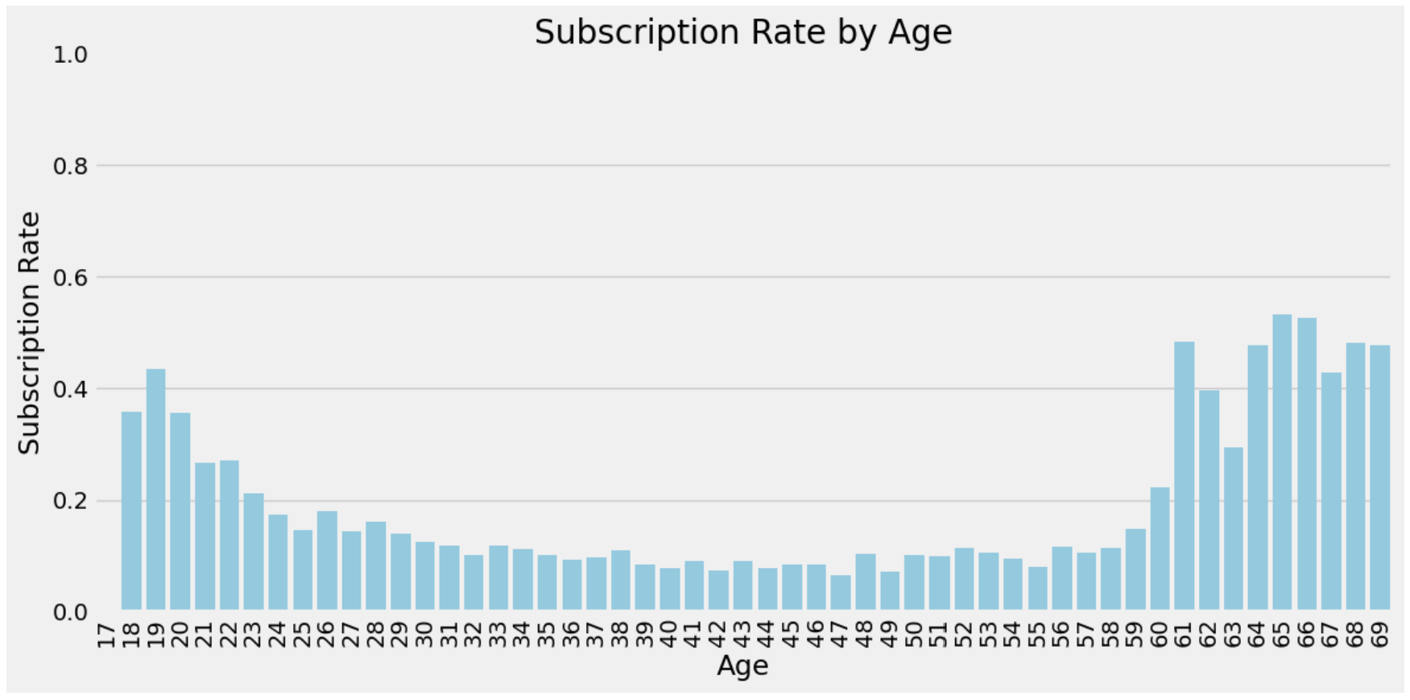

**Younger Ages (late teens to early 20s)** often show moderate-to-high subscription rates.

**Middle-Aged Clients (roughly 30–40 years old)** tend to have the **lowest** subscription rates.

**Older Clients (50+ years)** show a rising trend, sometimes surpassing 40–50% subscription

1. Housing by Subscription

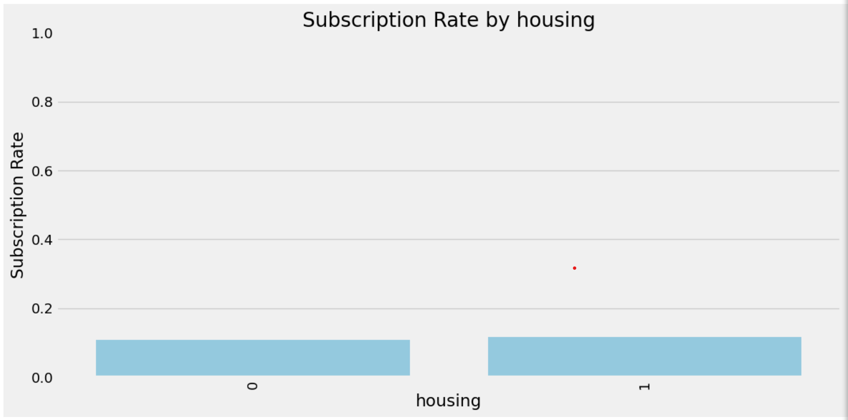

there’s a **slight** uptick in subscription rate among those with a housing loan, it’s not a major differentiator on its own.

**housing** is relatively balanced between those who subscribe and those who do not.

1. Loan by Subscription

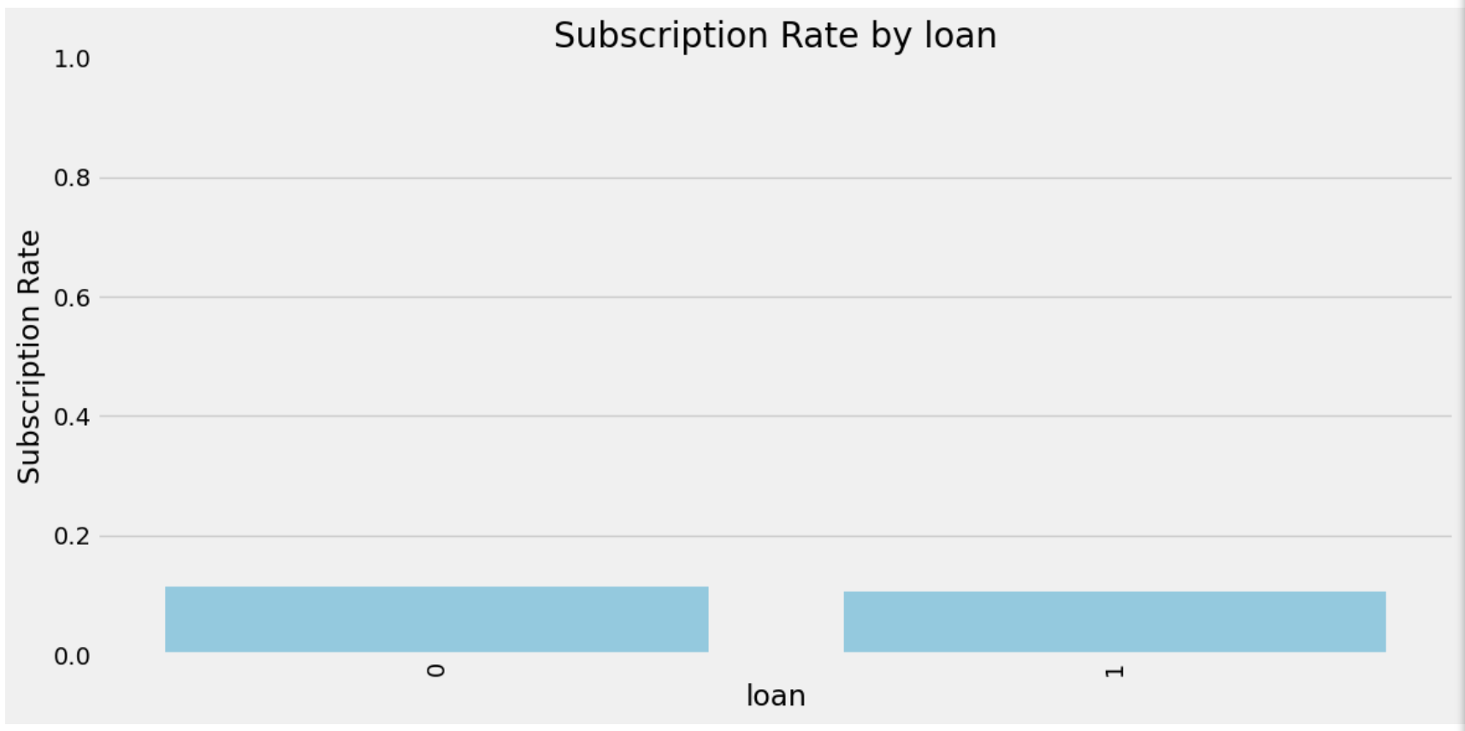

**most clients do not have a personal loan**, and non-subscribers are the largest group in both categories.

the **subscription rate** is only slightly higher or lower for those with a personal loan compared to those without, implying that **loan** status alone is not a strong standalone predictor.

1. Month by Subscription

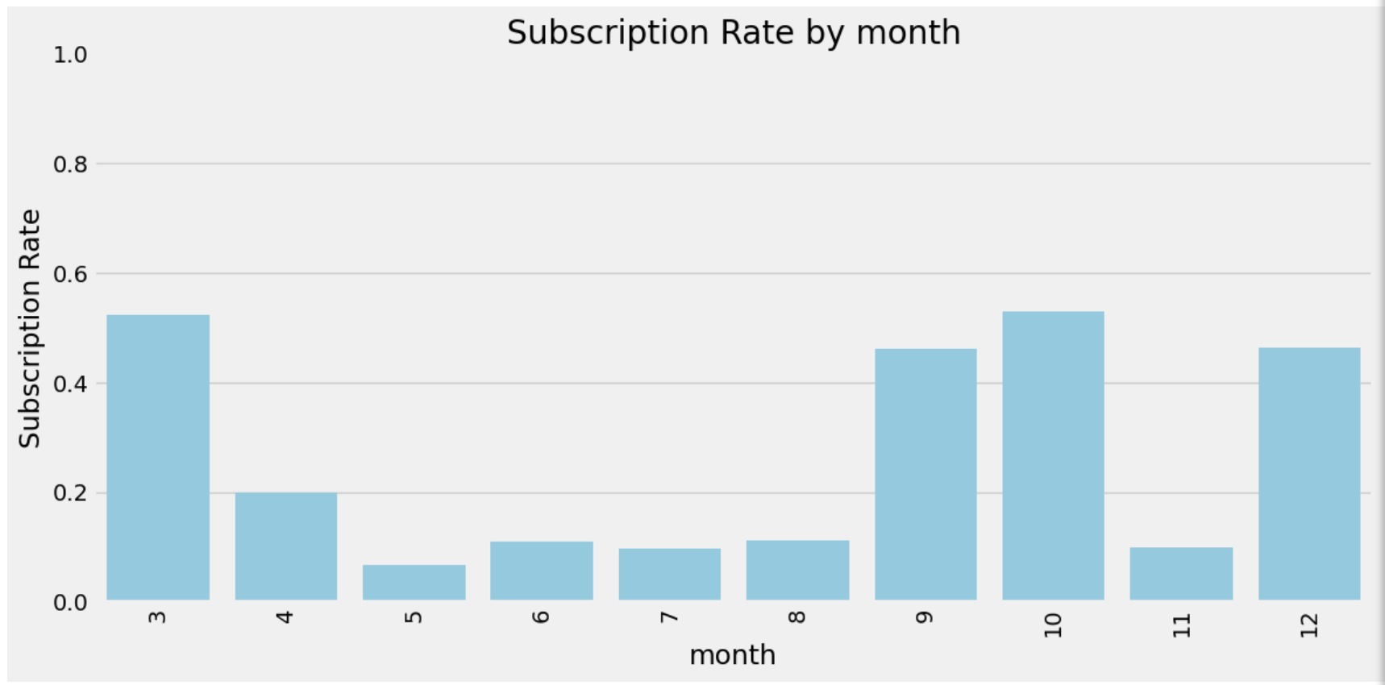

The plot suggests a **seasonal or campaign-related effect** on subscription likelihood, with notable peaks in some months.

1. Day of week by Subscription

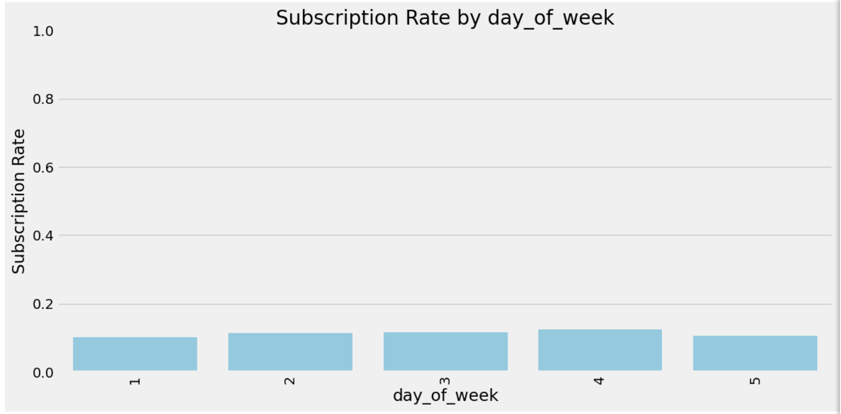

the **day_of_week** factor seems to have **little to no influence** on whether clients subscribe, based on these nearly uniform subscription rates.

1. Campaign by Subscription

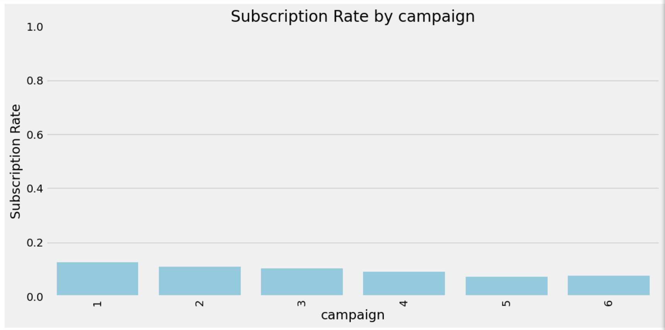

the chart indicates that **fewer contacts** often correlate with a **higher** subscription rate, highlighting the importance of **quality** over **quantity** in campaign calls.

1. Pdays by subscription

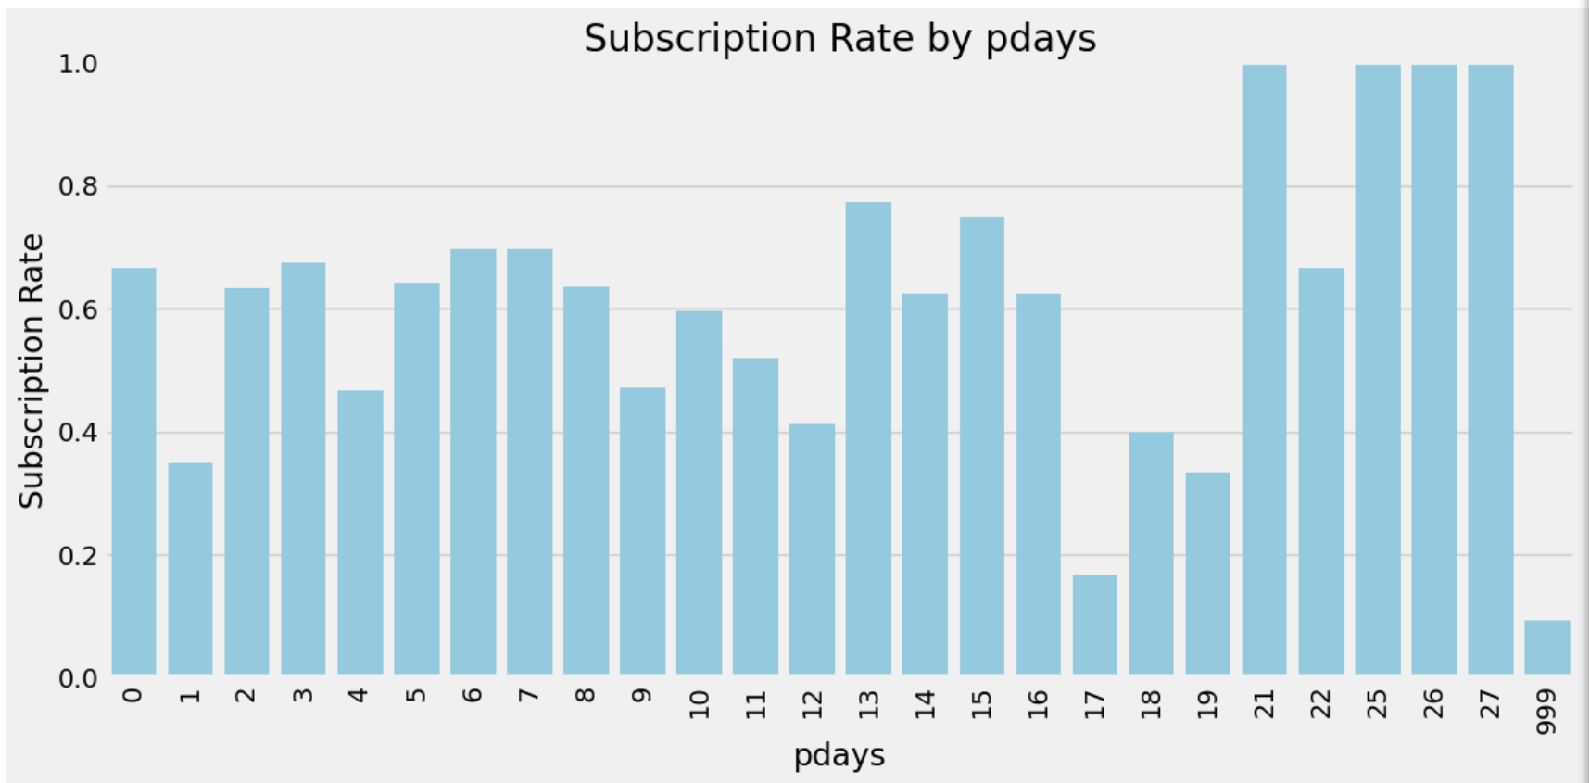

**pdays** reveals that clients previously contacted—even if it was many days ago—often have a higher propensity to subscribe than those never contacted (pdays=999). The exact subscription rate for each specific pdays value can be influenced by **sample size** and **timing** of the prior engagement.

1. Previous by Subscription

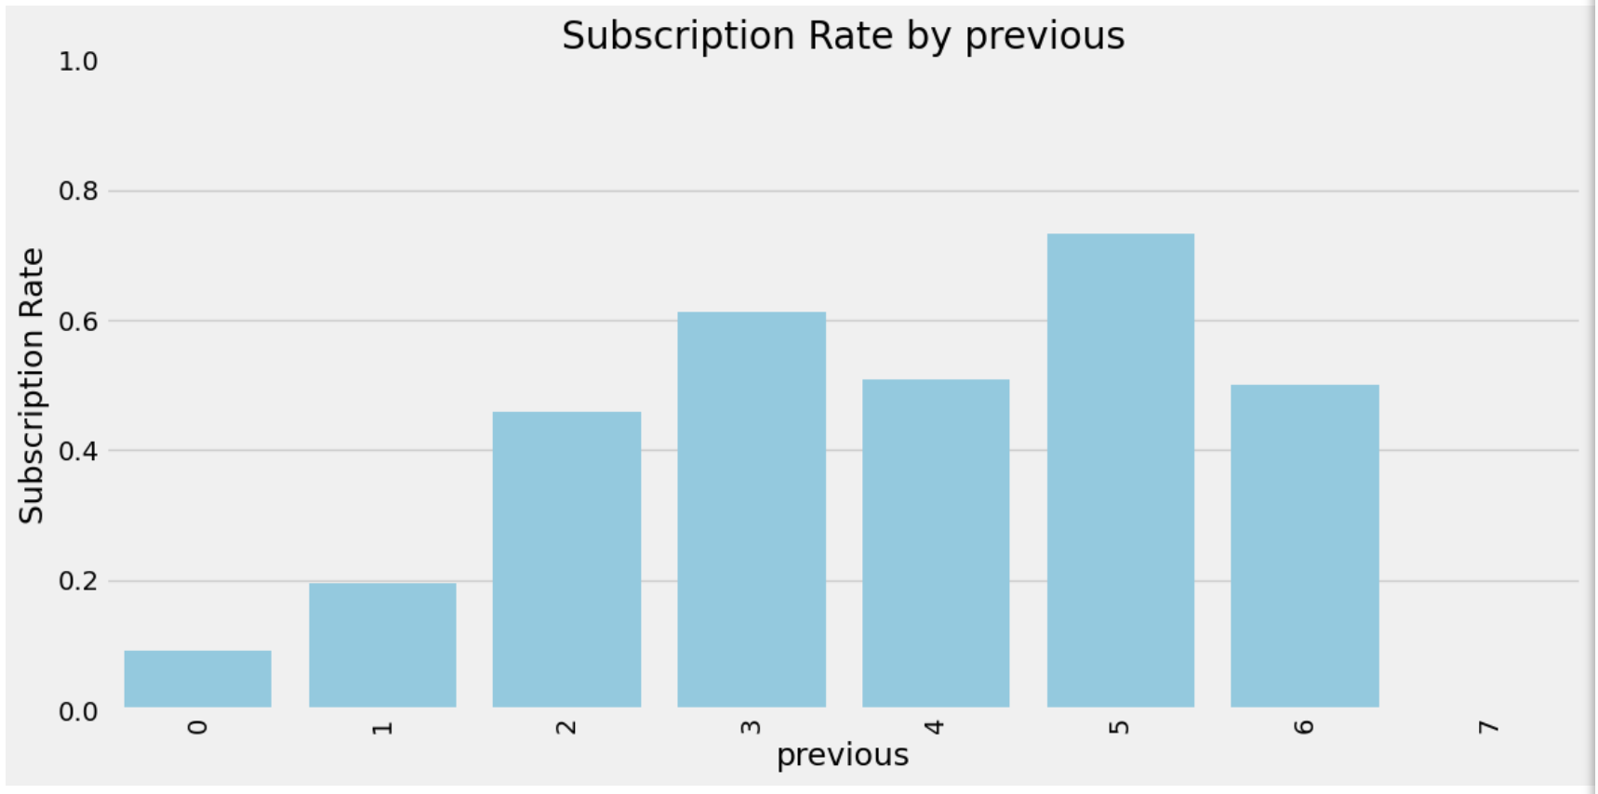

**previous contacts** strongly correlate with an increased likelihood of subscription—at least up to a certain point. This underscores the value of **long-term engagement** strategies and maintaining a consistent relationship with clients over multiple campaigns.

1. Emp_var_rate by Subscription

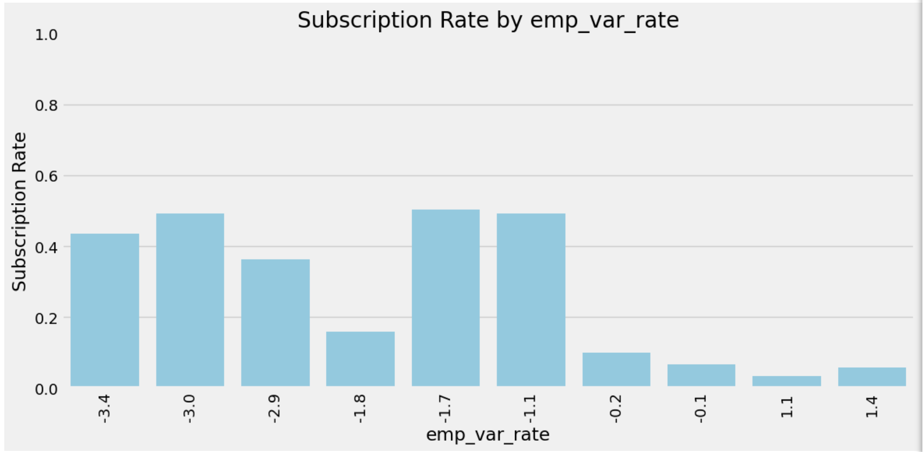

the chart suggests that **lower (negative) employment variation rates** correlate with **higher** subscription rates, possibly reflecting economic conditions that make term deposits more appealing. Deeper time-series analysis or cross-checking with other macro variables can clarify whether this relationship is consistent across different periods or specific to certain campaigns.

1. Cons_price_idx by Subscription

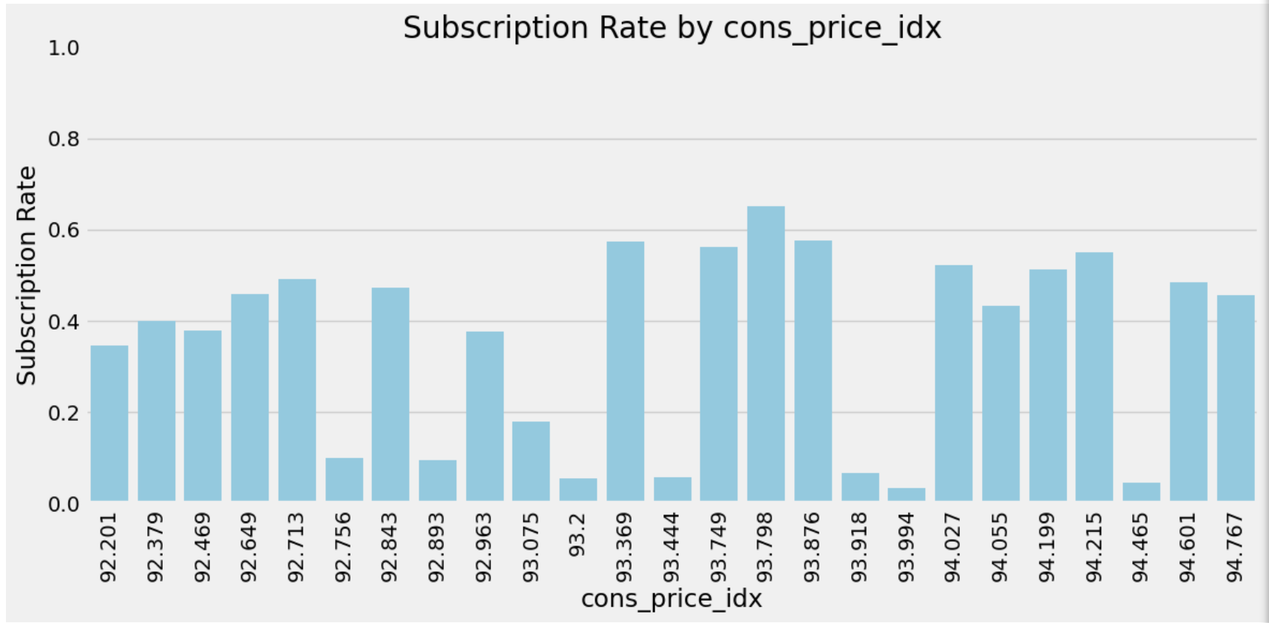

**consumer price index** shows varying subscription rates across different values, suggesting that **economic context** can influence client decisions. Further time-based or multivariate analysis can clarify whether these fluctuations are driven by true economic factors or sample distribution nuances.

1. Cons_conf_idx by Subscription

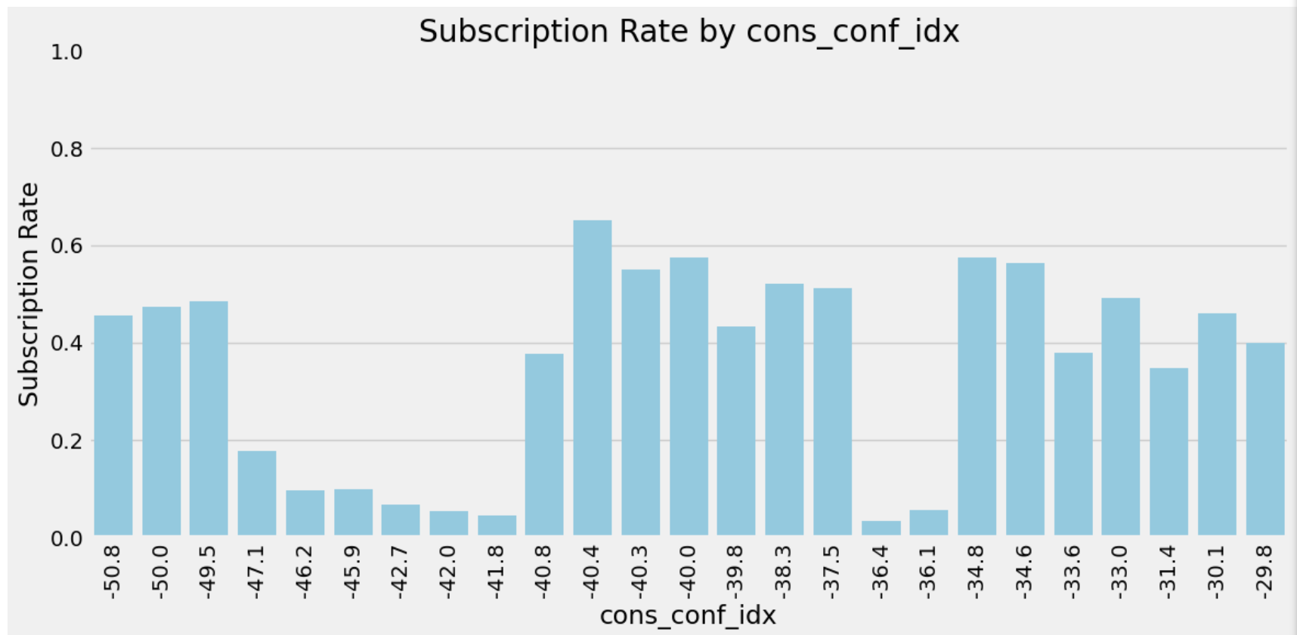

**consumer confidence** appears to influence subscription rates to some extent, though not in a strictly linear fashion. Exploring **time-based patterns** and combining cons_conf_idx with other economic indicators could yield deeper insights into how shifts in consumer sentiment affect term deposit subscriptions.

1. Euribor3m by Subscription

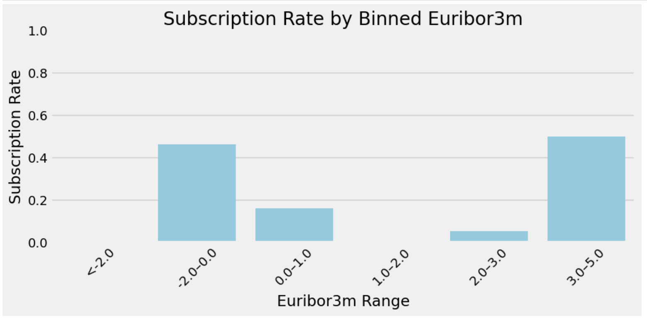

the plot shows that **subscription behavior** can differ significantly across **Euribor ranges**, likely reflecting **distinct economic contexts** in each bin.

1. Nr_employed by subscription

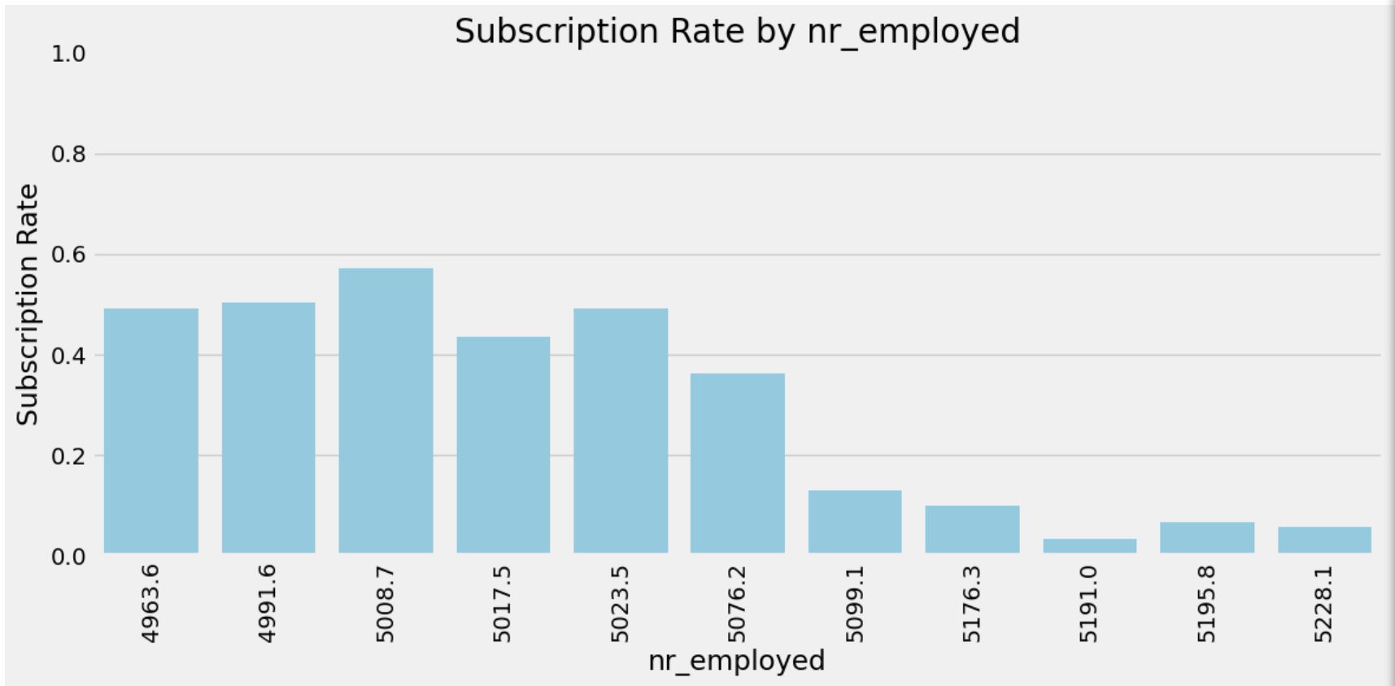

this chart indicates that **fewer employed individuals** (lower nr_employed) correlate with **higher** subscription rates, potentially reflecting an economic climate in which clients turn to safer investments like term deposits.

1. Previously_contacted by Subscription

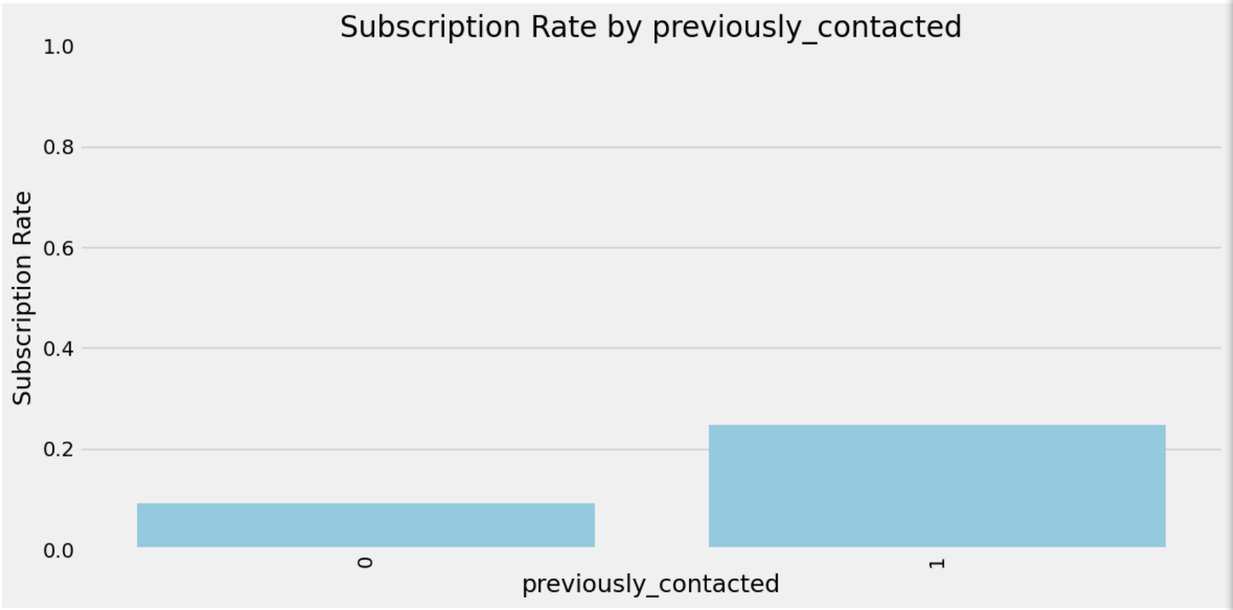

the chart indicates that **previous contact** is a meaningful predictor of term deposit subscriptions. Clients who have already interacted with the bank show a stronger inclination to subscribe than those being contacted for the first time.

1. Pdays_contacted by Subscription

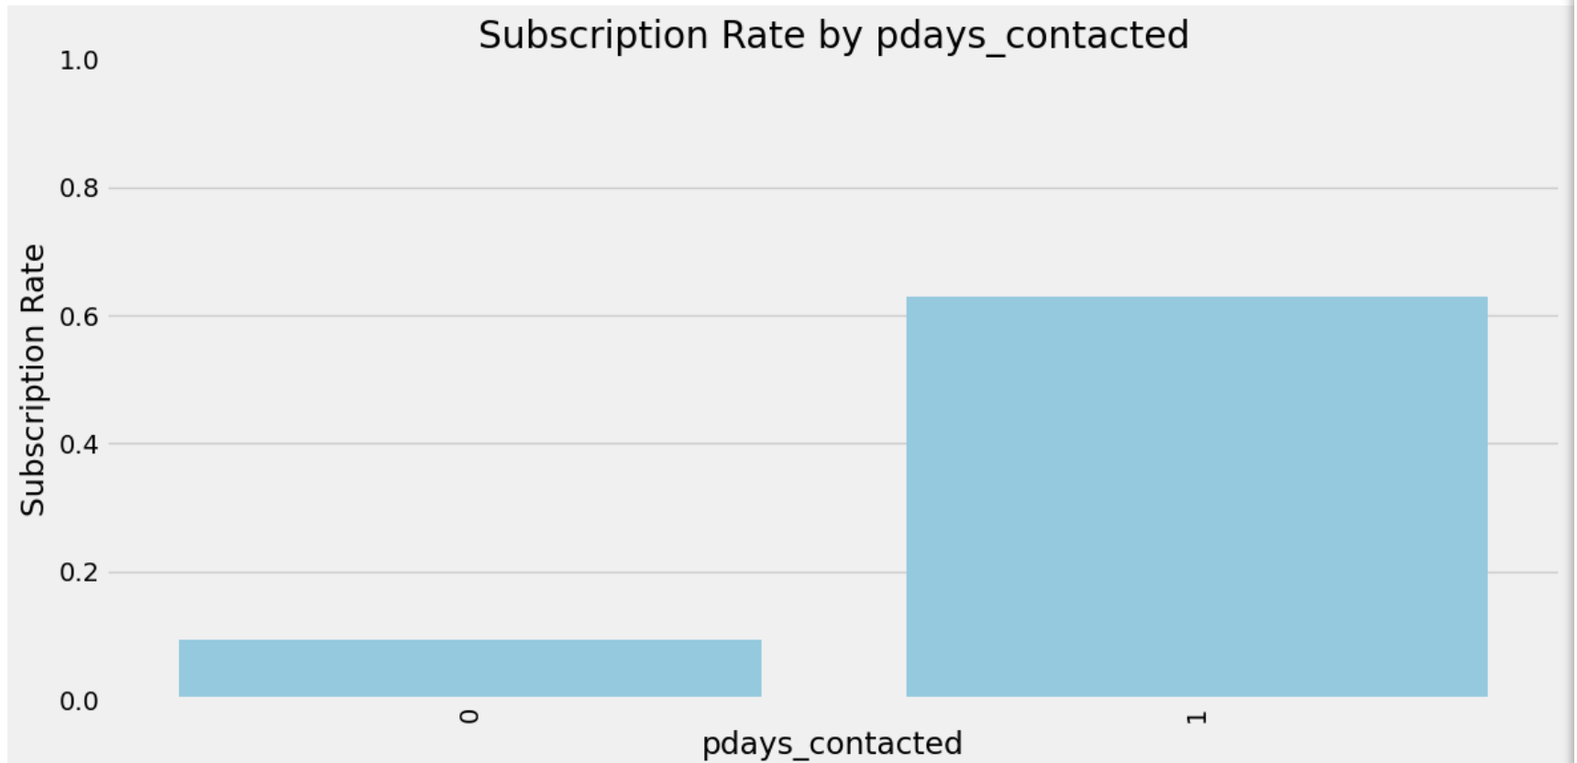

this chart highlights that **any form of prior contact** (indicated by pdays_contacted=1) significantly increases the likelihood of subscribing to a term deposit compared to clients who have never been contacted.

# Categorical features vs Target

1. Job by Subscription

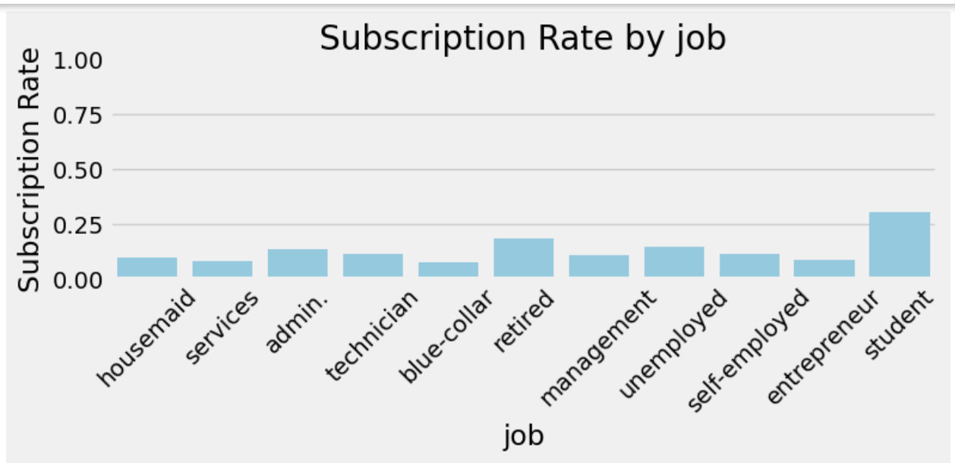

the chart highlights **significant variation** in subscription likelihood across different occupations. Higher subscription rates among students and retirees, for example, may point to **lifestyle factors** or **financial priorities** that make term deposits more appealing in those groups.

1. Marital by Subscription

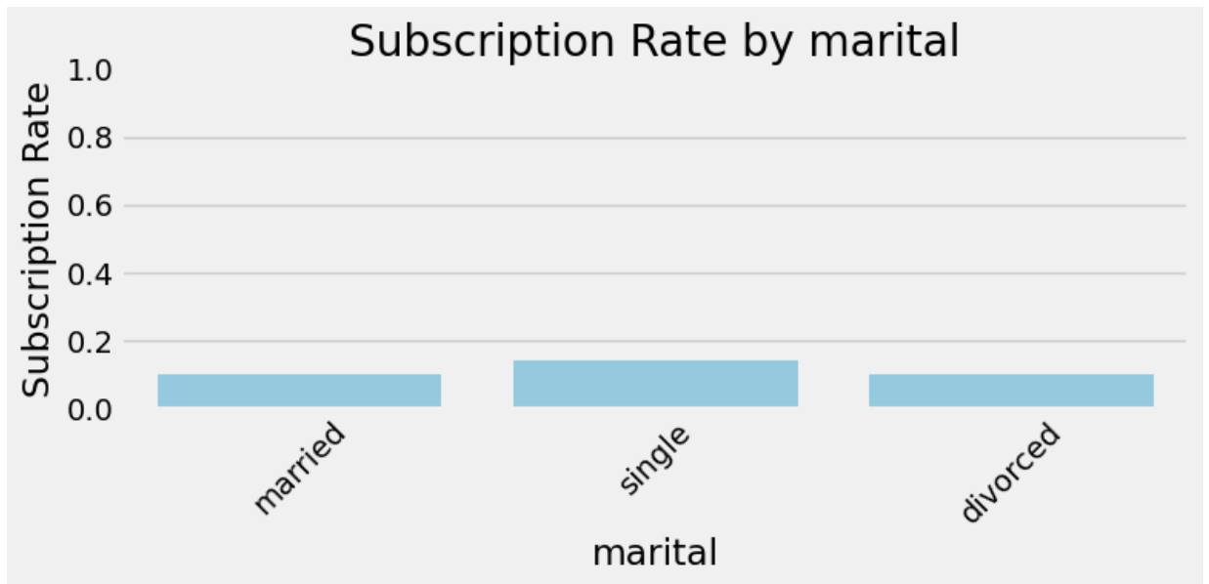

the chart indicates **minimal variation** in subscription rates by marital status, suggesting that **other variables** (e.g., previous contact, job, age) may play a more substantial role in determining whether a client subscribes.

1. Education by Subscription

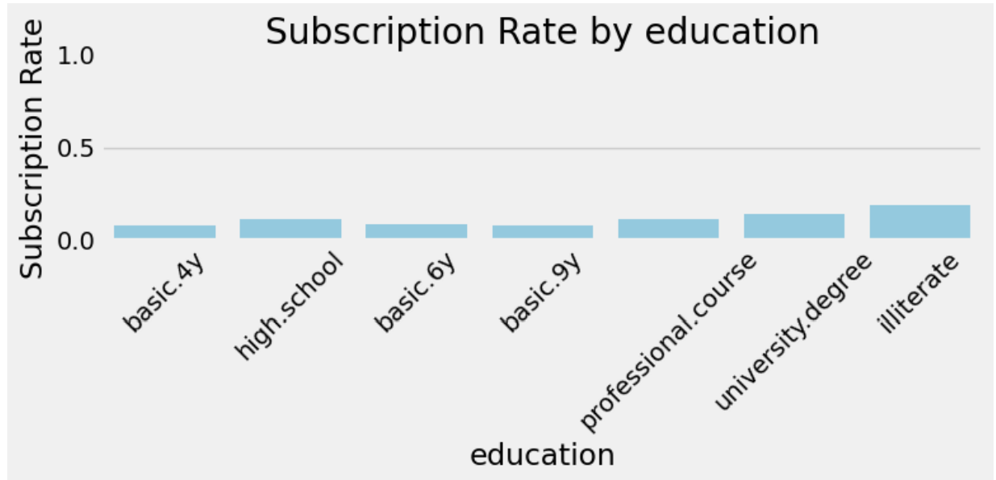

the chart suggests **little variation** in subscription rates by education alone, though small-sample effects (e.g., illiterate) can create minor spikes. Deeper analysis with additional variables or different grouping strategies may yield more actionable insights.

1. Default by Subscription

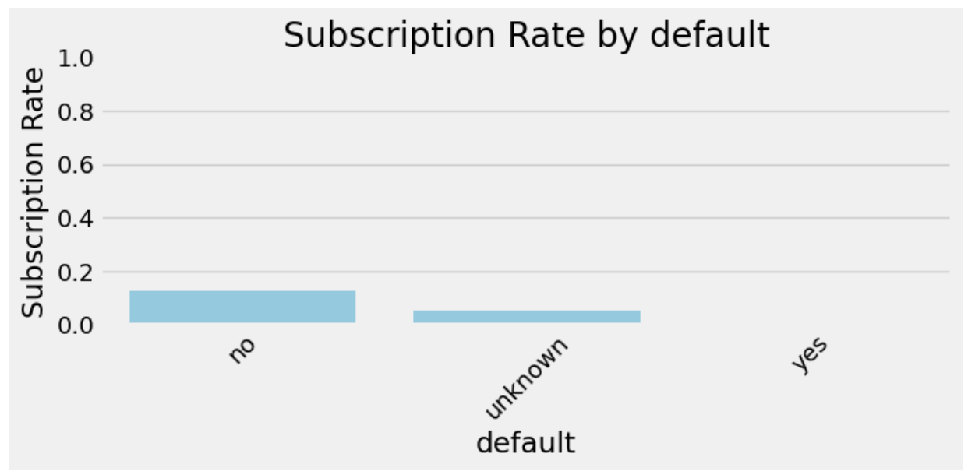

the plot indicates that **default** status (as recorded) has **limited impact** on subscription rates in this dataset, especially since “yes” defaults are extremely rare and “unknown” can be ambiguous.

1. Contact by Subscription

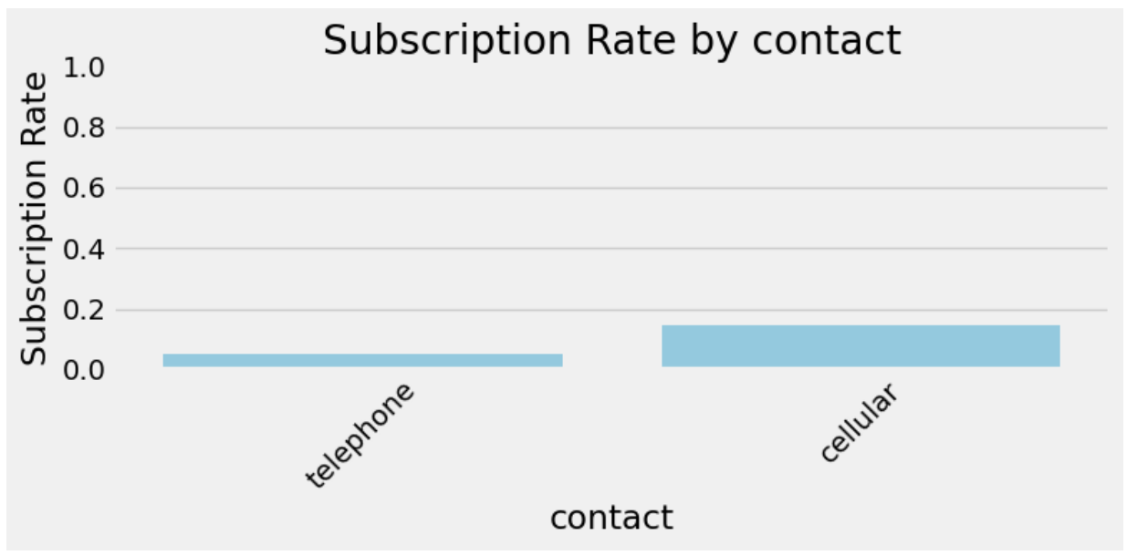

the plot shows that **cellular contacts** have a **higher** subscription rate than **telephone** contacts. This insight can inform the bank’s **marketing strategy**, possibly emphasizing mobile outreach to boost conversions.

1. Poutcome by Subscription

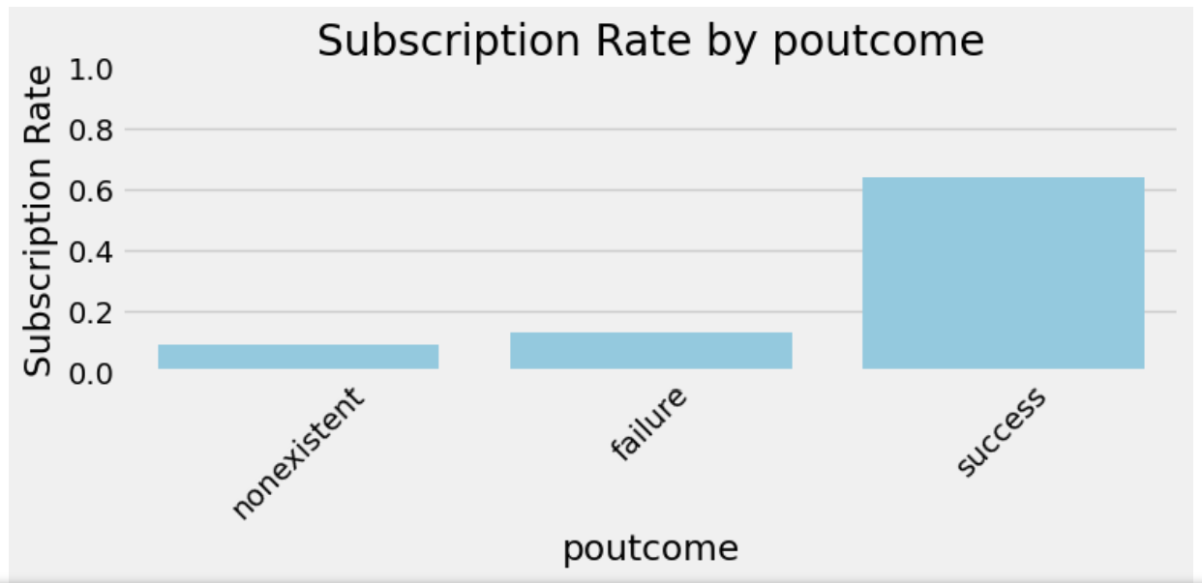

**poutcome** is a powerful feature for predicting term deposit subscriptions: clients who previously **succeeded** are much more likely to subscribe again, highlighting the value of **positive prior engagement**.

# Correlation matrix:

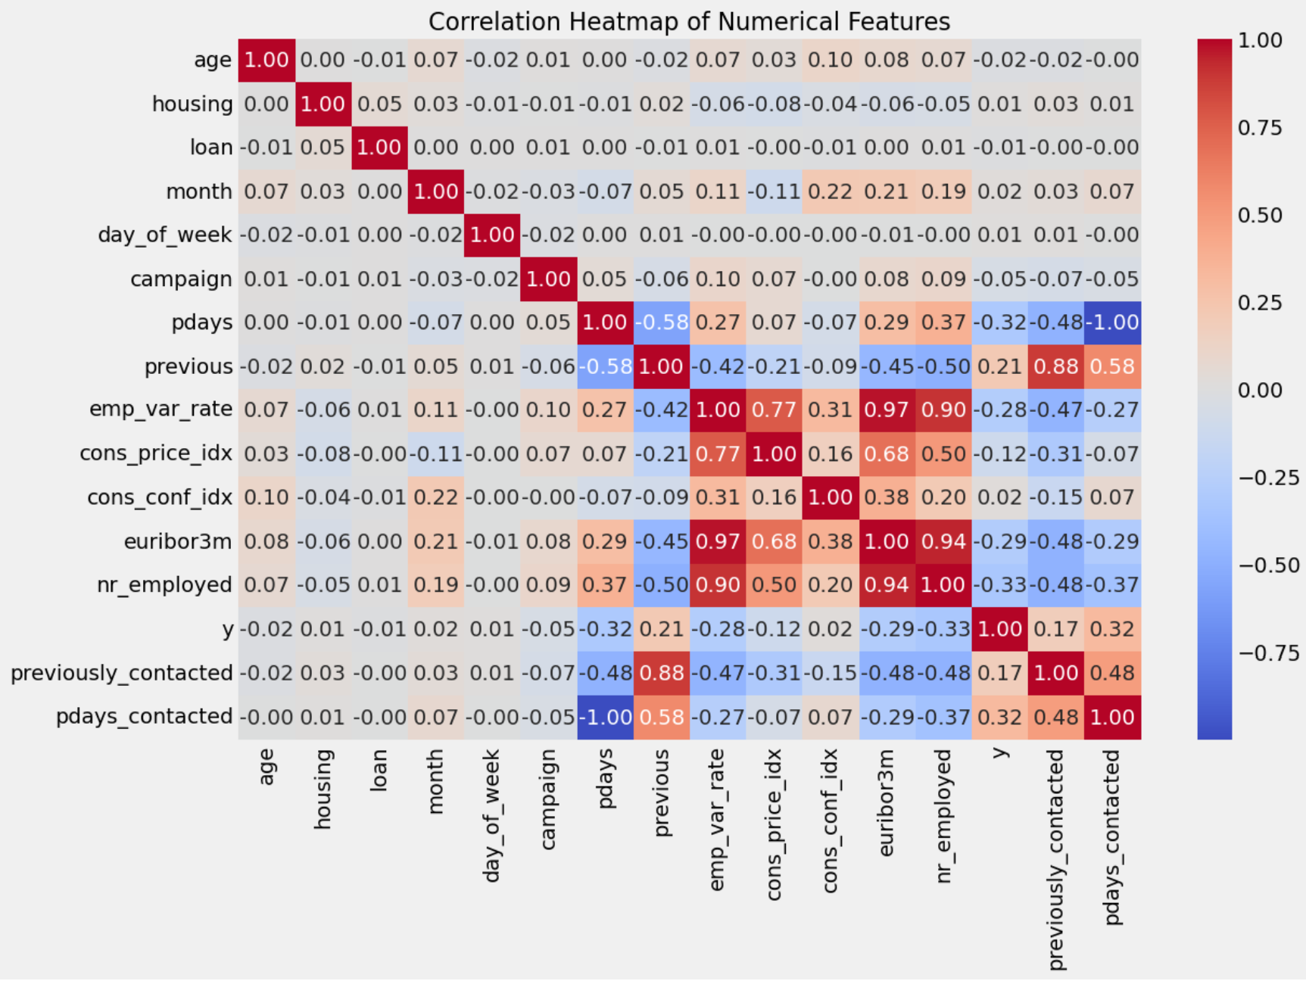

Below is a concise summary of the **correlation heatmap** among the numerical features, including the target variable (y):

1. **No Single Strong Predictor of y**
   * All correlations with y (the last row/column) are **relatively low**—generally below 0.3.
   * **previously_contacted** and **pdays_contacted** show the highest positive correlations with y, indicating that clients who have been contacted before are somewhat more likely to subscribe, but the correlation is still modest.
2. **Macro-Economic Variables**
   * **emp_var_rate, euribor3m, and nr_employed** are strongly correlated with each other (large red blocks).
   * **cons_conf_idx** (consumer confidence) is strongly negatively correlated with those variables.
   * **Implication:** These features may cause **multicollinearity** in linear models. Consider **regularization** (Ridge/Lasso) or **feature engineering** (e.g., PCA, combining correlated variables) to mitigate overlapping information.
3. **Campaign-Related Variables**
   * **campaign, pdays, and previous** show mild correlations with each other and y.
   * However, when converted into flags like **previously_contacted** or **pdays_contacted**, we see a more direct positive relationship with yyy. This suggests **prior contact** is a meaningful predictor of subscription.
4. **Housing and Loan**
   * **housing** and **loan** have very low correlations with yyy. This implies having a housing loan or personal loan alone does not strongly impact subscription decisions, at least in a linear sense.
5. **Age**
   * **age** exhibits minimal correlation with yyy. Non-linear relationships (e.g., a U-shaped pattern in subscription rate by age) may not appear in a simple Pearson correlation.
6. **Modeling Takeaways**
   * Because **no single feature** has a high correlation with yyy, a **multi-feature** or **non-linear** approach (e.g., tree-based models) will likely perform better.
   * The **macro-economic** features need careful handling due to their strong inter-correlations.
   * **Previous contact** indicators (previously_contacted, pdays_contacted) are relatively more predictive and could be critical in the final model.

Overall, the heatmap highlights a **multi-factor** environment with modest linear correlations to ‘y’. Key insights include the importance of **previous contacts** and the caution required when using **macro-economic variables** due to their high inter-correlations.

# Multivariate Analysis

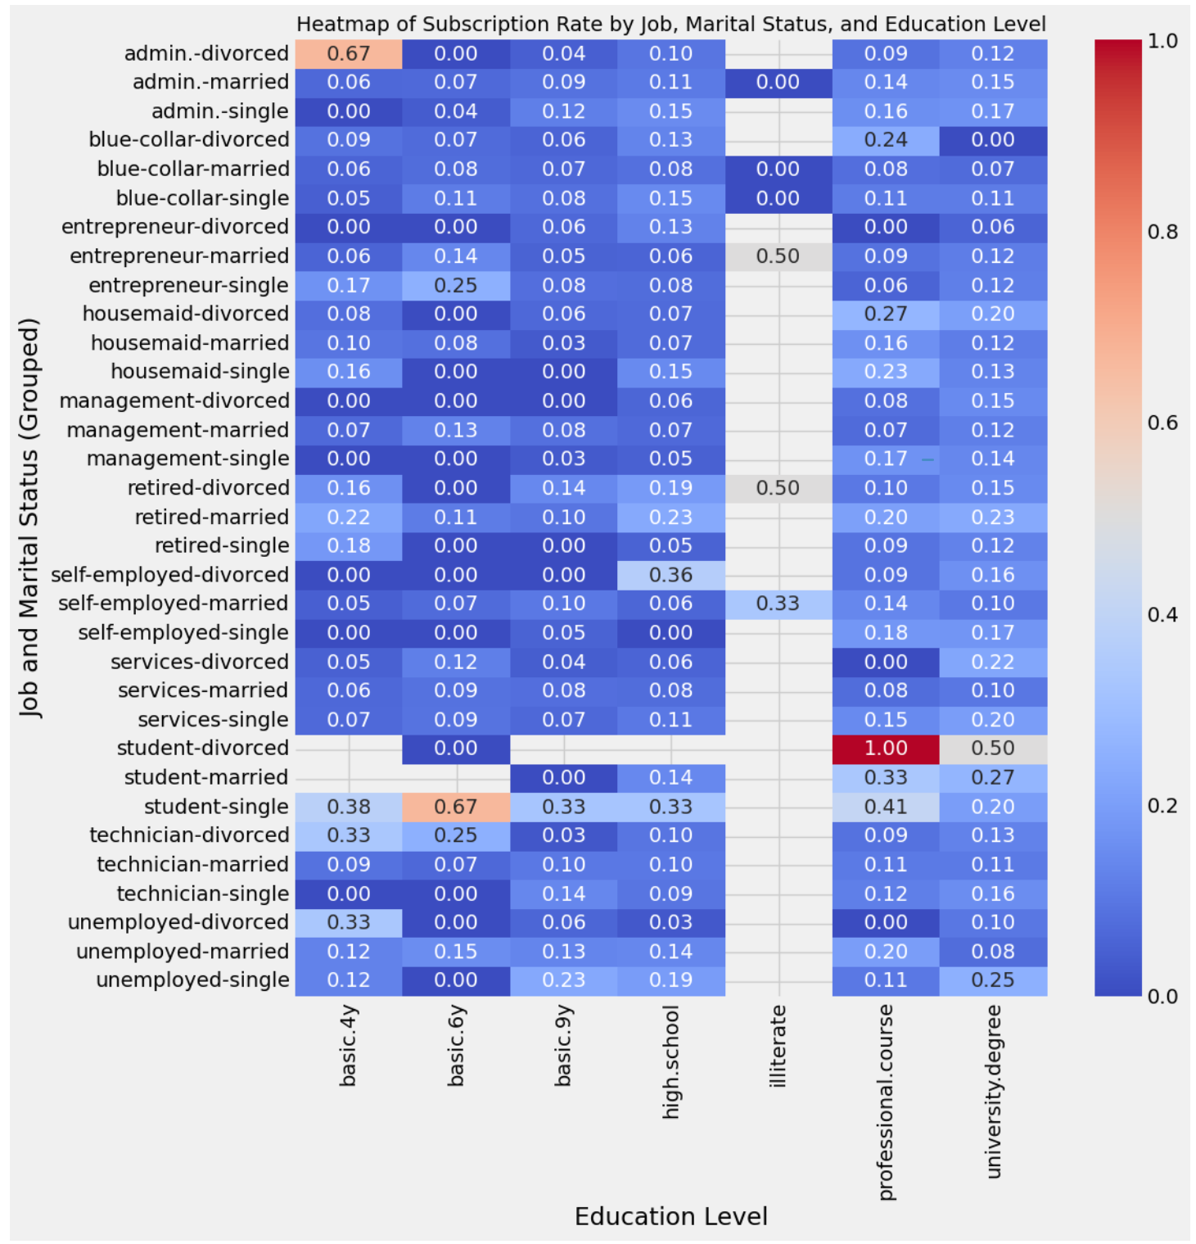

**Observations**

1. **Higher Subscription Clusters**
   * **Students** and **Retirees** frequently show higher subscription rates across multiple education levels.
   * **Entrepreneurs** and certain other professions also have elevated rates, though the pattern is more mixed.
2. **Impact of Marital Status**
   * **Single** individuals in certain jobs (e.g., admin, blue-collar) sometimes have higher subscription rates compared to their married or divorced counterparts.
   * However, this effect varies by job and education level, so marital status alone is not a simple predictor.
3. **Education Level Differences**
   * **Tertiary (university) education** often correlates with moderately higher subscription rates than basic or high school levels.
   * **Professional Courses** can spike subscription rates in some job groups (e.g., self-employed, services), but not universally.
4. **Notable Hotspots**
   * Cells with **values above 0.60** (in orange or red) indicate particularly high subscription likelihood.
   * For instance, “student-single” with high education may reach a subscription rate of ~0.67, whereas “retired-married” with a tertiary education might also show a strong rate (~0.53+).

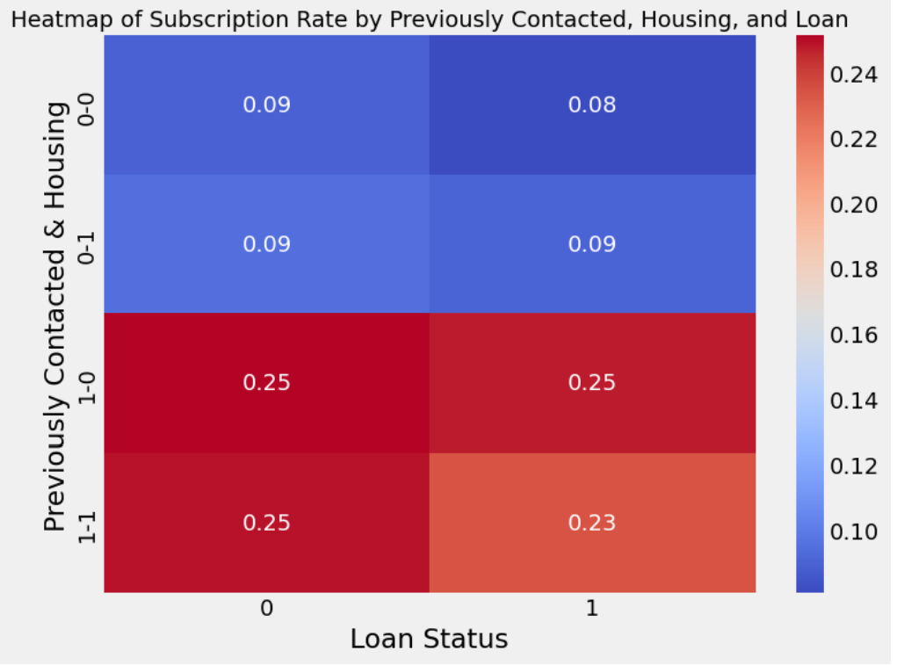

brief interpretation of your **heatmap** showing **subscription rates** by **Previously Contacted**, **Housing**, and **Loan**:

1. **Strong Influence of “Previously Contacted”**
   * The bottom two rows (where previously_contacted=1) have **significantly higher** subscription rates (around 0.23–0.25) compared to the top rows (0.08–0.09).
   * This highlights that clients who were previously contacted in a past campaign are roughly **2–3 times** more likely to subscribe now.
2. **Modest Differences for Housing and Loan**
   * Within each previously_contacted group, having a housing loan (housing=1) or a personal loan (loan=1) makes **only a small difference** in the subscription rate.
   * For example, among those not previously contacted (previously_contacted=0), the subscription rate is around 0.09 whether or not they have a housing loan or personal loan.
   * Similarly, for those who were previously contacted, the rate hovers around 0.23–0.25, regardless of housing or loan status.
3. **Key Takeaway**
   * **Prior engagement** (i.e., being contacted before) is the dominant factor in predicting whether a client subscribes.
   * Housing and loan status appear to have **minimal** impact on subscription likelihood compared to the strong effect of previously_contacted.
4. **Practical Implications**
   * **Re-engage Past Contacts:** Since previously contacted clients are far more likely to subscribe, focusing follow-up efforts on those who have interacted with the bank before can significantly boost conversion rates.
   * **Secondary Role for Loan/Housing:** While not unimportant, these features do not substantially shift subscription rates on their own. You might still include them in a predictive model, but the data suggests they won’t be as strong as the “previously contacted” indicator.

Overall, the heatmap confirms that **previous contact history** is a powerful predictor of subscription, overshadowing any incremental differences introduced by housing or loan status.

# Classifier Models

## Baseline model:

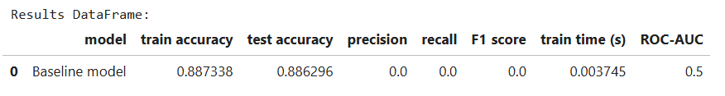

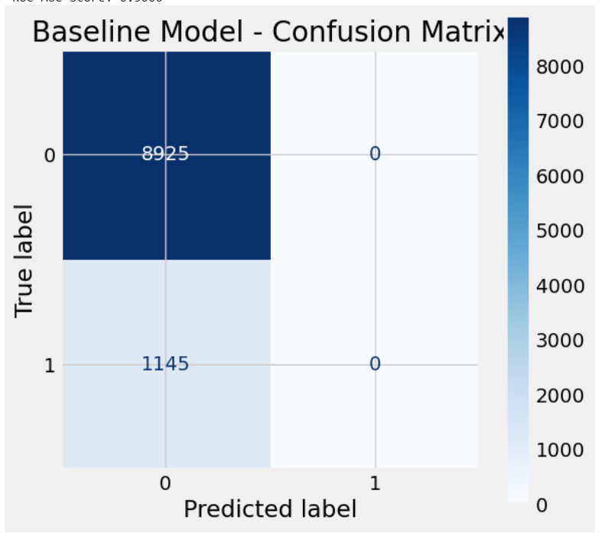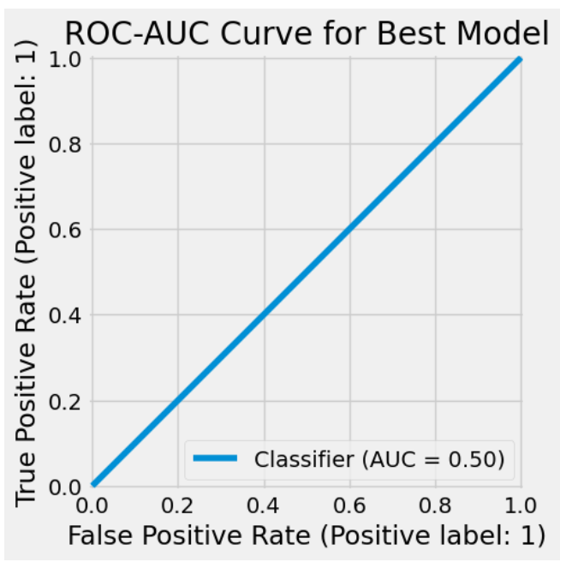

**Interpretation**

* This baseline model always predicts the majority class (no subscription).
* While it achieves decent accuracy (~88.6%) by exploiting class imbalance, it misses all actual positives (recall = 0).
* The AUC of 0.50 confirms it has no discriminative ability for identifying true subscribers.

## KNN Classifier

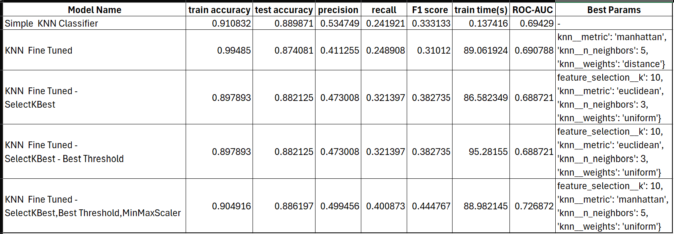

**Summary of Findings**

1. **Simple KNN Classifier (Row 1)**
   * **Highest test accuracy** (0.8899) but **lowest recall** (0.2419) and a modest ROC-AUC (0.6943).
   * **Fastest training** (0.14 s).
2. **KNN Fine Tuned (Row 2)**
   * Overfits heavily (train accuracy ~0.995, test accuracy ~0.8741).
   * Does not outperform the simple classifier on test metrics; lower F1 (0.3101) and similar recall (0.2489).
3. **KNN Fine Tuned + SelectKBest (Row 3)**
   * Sacrifices some test accuracy (0.8821) but **gains higher recall** (0.3214) and F1 (0.3827) compared to the simple classifier.
   * ROC-AUC (0.6887) is slightly below the simple model’s 0.6943.
4. **KNN Fine Tuned + SelectKBest + Best Threshold (Row 4)**
   * Identical metrics to Row 3, indicating no threshold change in practice.
   * Longer train time, so no net improvement over Row 3.
5. **KNN Fine Tuned + SelectKBest + Best Threshold + MinMaxScaler (Row 5)**
   * **Highest recall** (0.4009) and **highest F1** (0.4448) in the table.
   * Test accuracy (0.8862) is close to the simple model’s 0.8899.
   * **Best ROC-AUC** (0.7269).
   * Training time is significant (~89 s), but if you need better recall/F1, this approach is best overall.

### Simple KNN

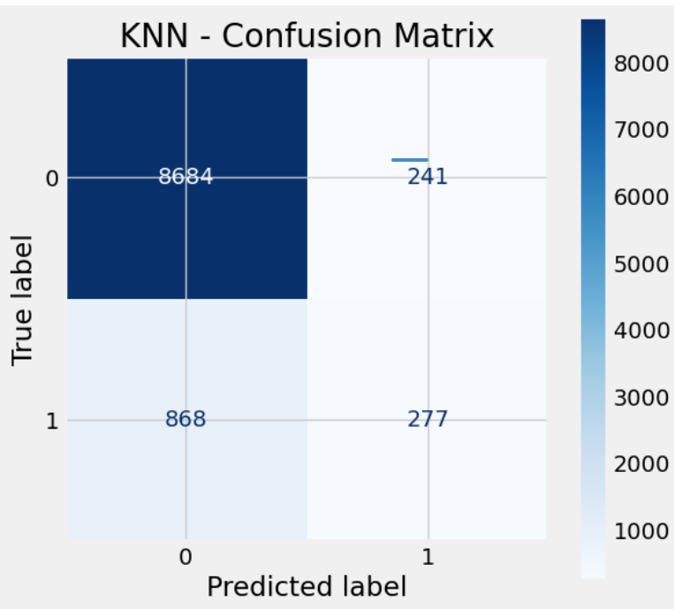 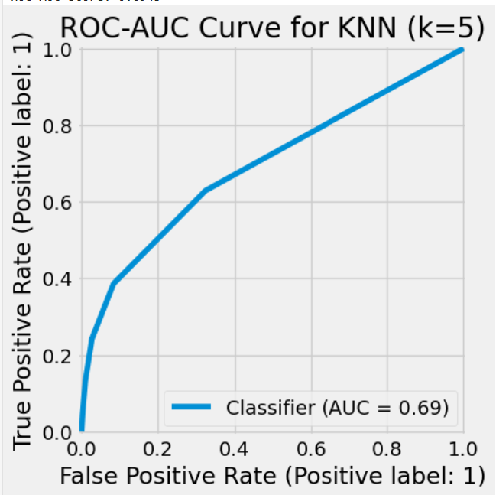

**Interpretation**

* **High True Negatives**: The model is good at predicting the majority class (0) correctly (8684 TN vs. only 241 FP).
* **Low Recall**: The model struggles with detecting positive cases (only 277 TP vs. 868 FN), which leads to a low recall (~0.24).
* **Moderate Precision**: When the model does predict a positive, it is correct about half the time (~53.5%).
* **ROC-AUC = 0.69**: This is moderately better than random but suggests the model’s probability ranking could be improved.

### KNN fine-tuned

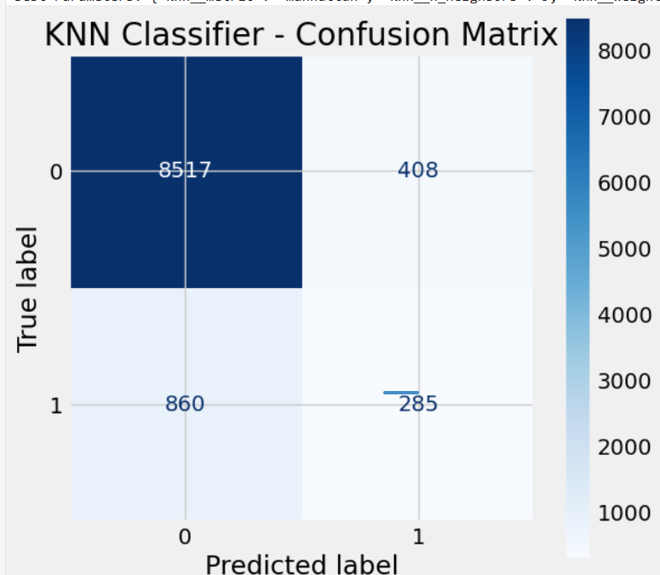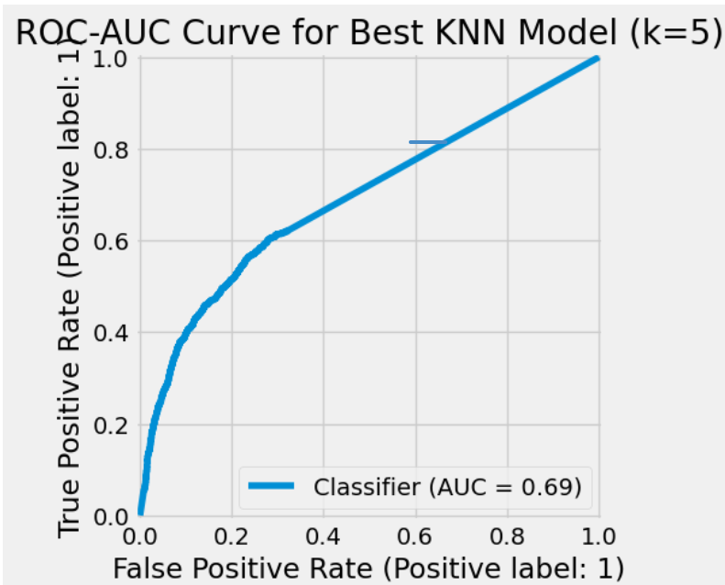

**Interpretation**

1. **High True Negatives**
   * The model correctly identifies most negatives (8517 out of 8925 total negatives), resulting in an overall accuracy of ~87.4%.
2. **Low Recall**
   * With only 285 out of 1145 actual positives correctly identified, the model has a **recall of ~25%**. It’s missing the majority of positive cases.
3. **Moderate Precision**
   * At ~41%, the model is somewhat conservative about labeling positives, but when it does, it’s only correct a little less than half the time.
4. **ROC-AUC = 0.69**
   * The model’s probability estimates provide some separation between classes, but there is **significant room for improvement**.

### KNN fine-tuned with feature selection

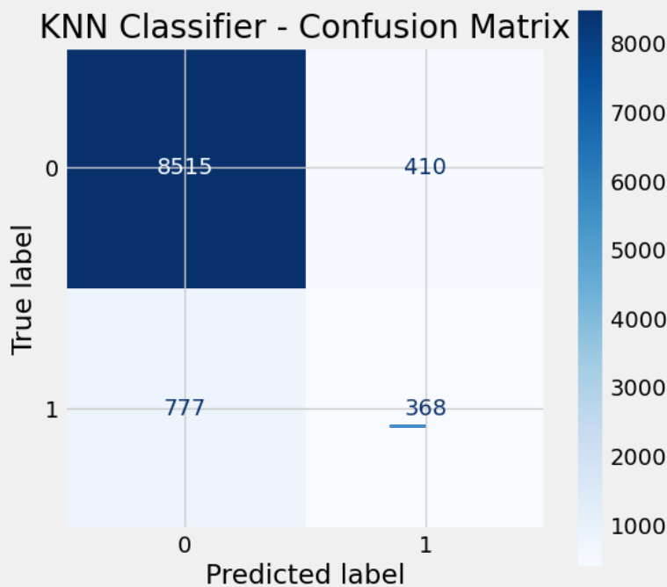 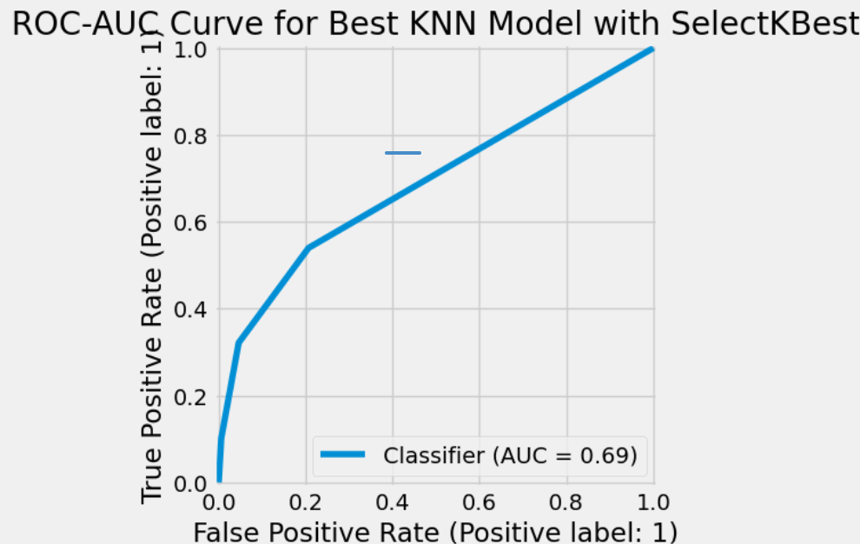

**Interpretation**

1. **Good Overall Accuracy**
   * At **88.2%**, the model is strong at identifying the majority (negative) class.
2. **Moderate Precision, Low Recall**
   * **Precision ~47%** means that when the model flags a positive, it’s correct less than half the time.
   * **Recall ~32%** means it misses most of the true positives, which could be problematic if your application requires catching as many positives as possible.
3. **ROC-AUC = 0.69**
   * Indicates that while the model does rank positive cases better than chance, there is significant room for improvement in probability discrimination.

### KNN fine-tuned with feature selection and threshold tuning

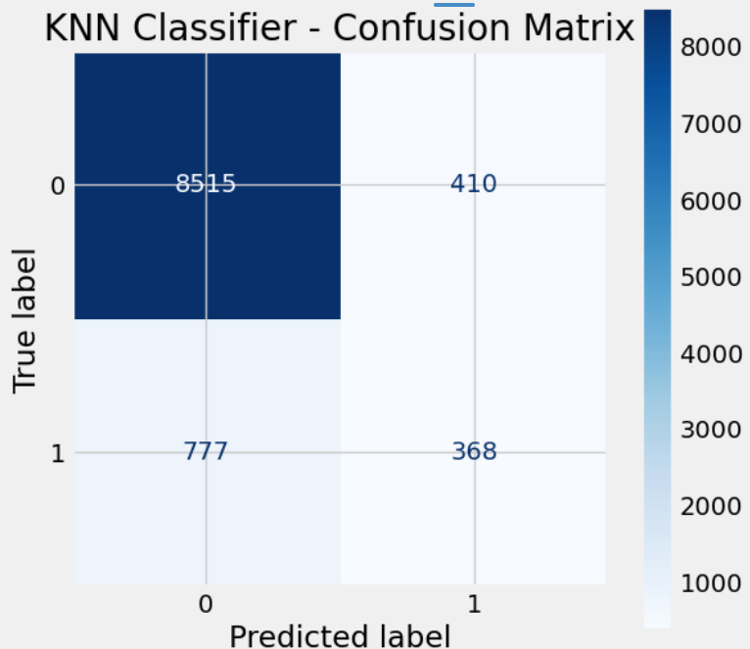 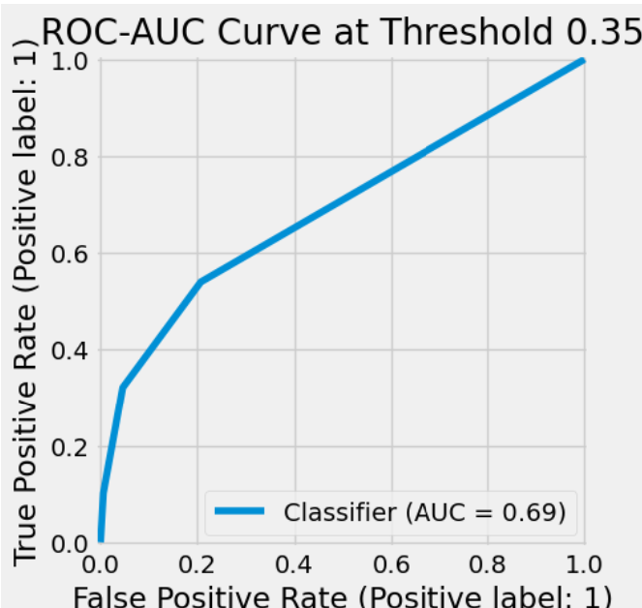

**Interpretation**

1. **Good Overall Accuracy, Low Recall**
   * The model achieves **88.2%** accuracy, primarily by correctly classifying the majority class (negative). However, it catches only ~32% of actual positives.
2. **Moderate Precision**
   * At ~47.3%, the model’s positives are not highly precise. Further threshold tuning or a different model may help.
3. **ROC-AUC = 0.69**
   * This is above random but indicates limited discriminative ability in probability ranking.

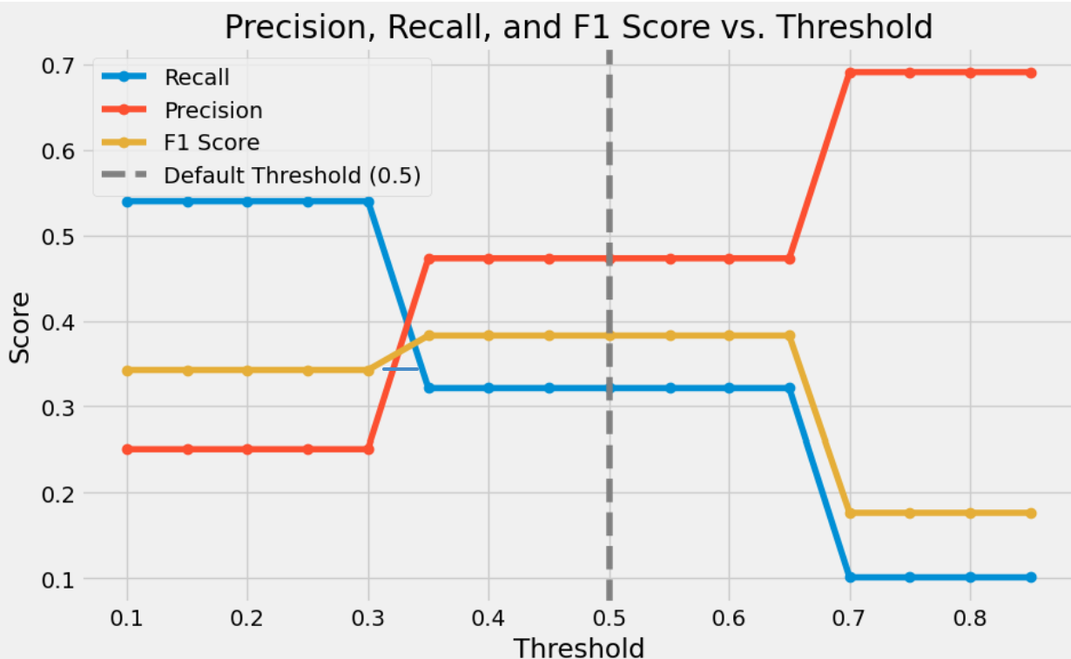

Observations:

* **Below 0.5**:
  + **Recall** is relatively high (~0.7), but **precision** is lower (~0.4).
  + **F1** is around 0.5, which is higher than at threshold 0.5.
* **At threshold = 0.5 (dashed line)**:
  + **Recall** drops to ~0.3.
  + **Precision** jumps to ~0.7.
  + **F1** drops to ~0.4 because the recall is too low.
* **Above 0.5**:
  + **Recall** stays low (~0.3), **precision** remains higher (~0.7), and **F1** stays around 0.4.

From this pattern, it looks like the **best F1** occurs **somewhere below 0.5** (roughly around 0.3–0.4).

### KNN fine tuned with feature selection and class_weight=’balanced’ (MinMaxScaler)

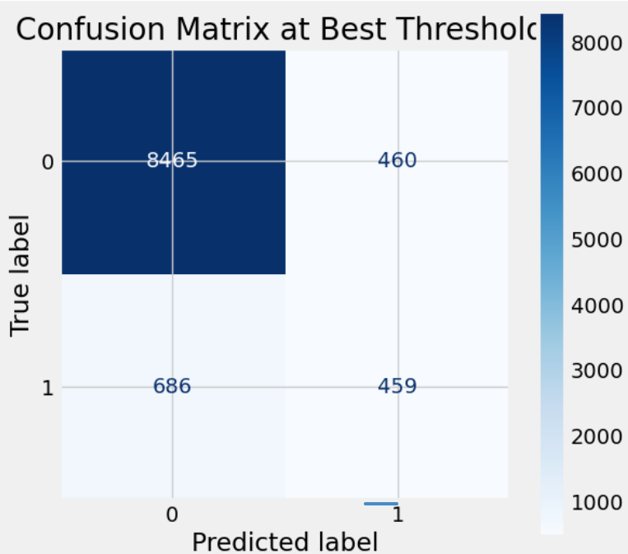 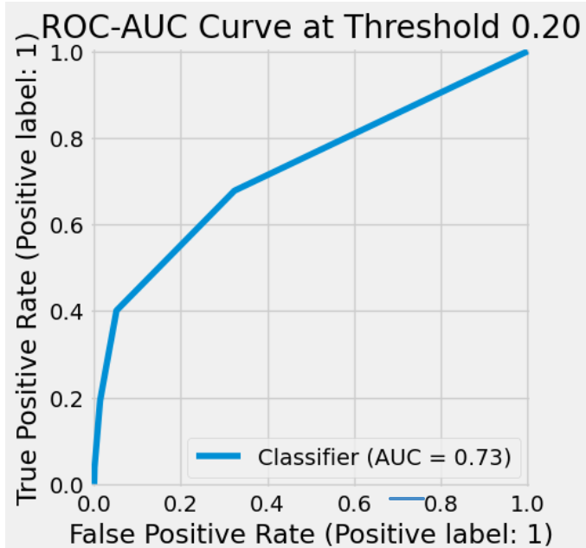

**Interpretation**

1. **Threshold at 0.20 Captures More Positives**
   * By lowering the threshold from 0.50 to 0.20, the model classifies more instances as positive, increasing **recall** from ~0.32 to ~0.40.
2. **Precision Remains Moderate (~0.50)**
   * While you catch more true positives, you also accept more false positives. Your precision is about 50%.
3. **Balanced Trade-off for Higher F1**
   * F1 (~0.445) is higher than when you used a default threshold of 0.50, indicating a better balance of precision and recall for many use cases.
4. **AUC = 0.73**
   * Suggests the model’s probability estimates separate positives from negatives better than random (0.5). There is still room for improvement if you need stronger discriminative power.

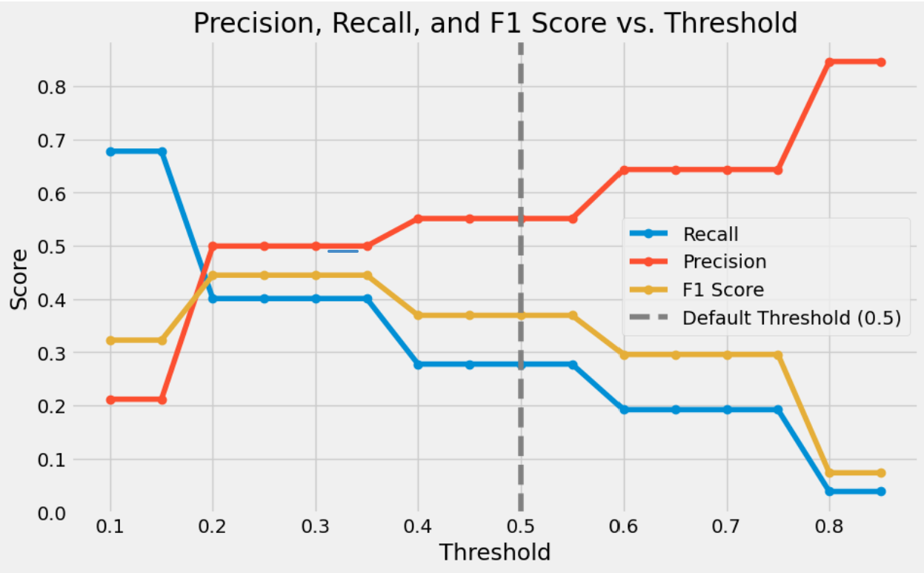

Observations:

1. **Threshold < 0.3**
   * + **High recall**, **low precision**, **moderate F1**.
     + You catch most true positives, but also produce many false positives.
2. **Threshold ~ 0.3–0.4**
   * + **F1 Score peaks** in this region, suggesting a good trade‑off between precision and recall.
     + For many applications that prioritize balanced performance, this range might be optimal.
3. **Threshold = 0.5 (Default)**
   * + Precision improves, but recall drops noticeably.
     + F1 typically decreases compared to its peak at lower thresholds.
4. **Threshold > 0.5**
   * + **High precision**, **low recall**, and a decreasing F1.
     + You’re very selective about labeling positives, so you miss more true positives.

## Logistic Regression Classifier:

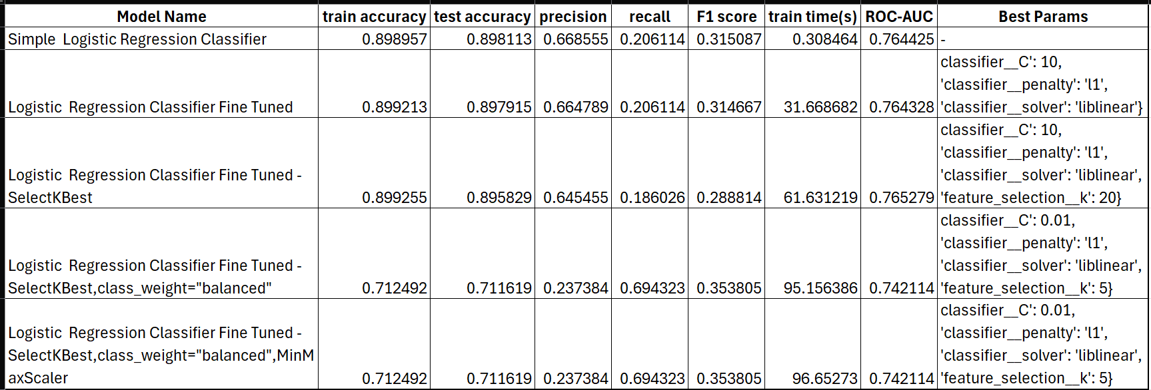

**Key Takeaways**

1. Rows 1–3:
   * High accuracy (~89–90%), low recall (~18–21%), moderate F1 (~0.29–0.31), and ROC-AUC (~0.76).
   * Minimal differences among “Simple” vs. “Fine Tuned” vs. “+SelectKBest.” The tuning or feature selection did not yield a substantial performance gain on the test set.
2. Rows 4–5 (class_weight="balanced"):
   * Drastically higher recall (~69.4%) but much lower precision (~23.7%) and accuracy (~71%).
   * The F1 (0.3538) is higher than the ~0.31 in Rows 1–2, so if you need to capture more positives, these models are better.
   * ROC-AUC dips to ~0.74 but is still reasonable.
3. When to Choose Each Model
   * If high accuracy or precision is a priority (and missing positives is acceptable), stick with Rows 1–3 (e.g., Simple Logistic Regression).
   * If higher recall or better F1 is needed (e.g., you can’t afford to miss positives), use Rows 4 or 5.
     + Both yield the same metrics, so MinMaxScaler did not help in this case.
4. Training Time
   * The baseline (Row 1) is very fast (~0.31 s) and has the highest accuracy among these.
   * The “balanced” models (Rows 4–5) take ~95+ seconds, largely due to feature selection with L1 penalty plus reweighting.

### Simple Logistic Regression

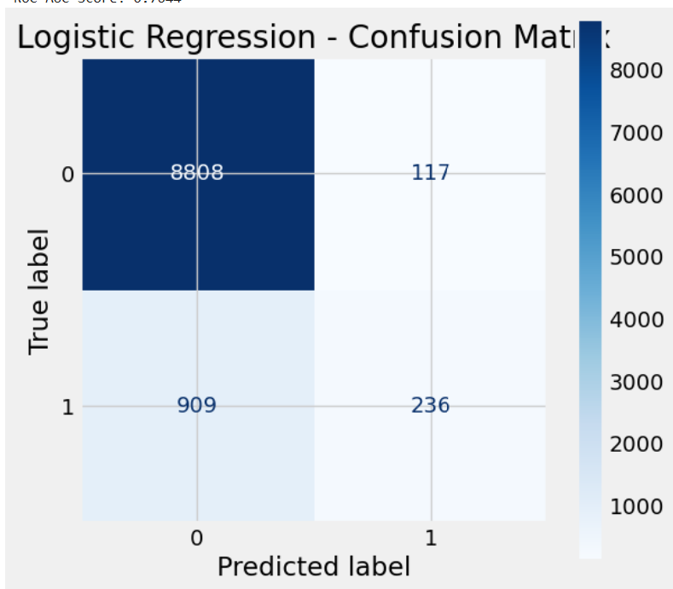 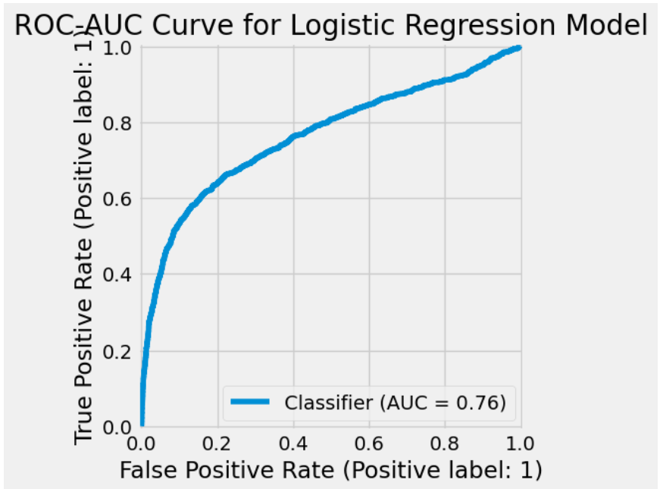

**Interpretation**

1. **High Accuracy, Low Recall**
   * The model is good at recognizing negatives (very few false positives), resulting in high accuracy (~89.9%).
   * However, it struggles to catch many positives (recall ~20.6%), which may be problematic if your application needs to identify as many positives as possible.
2. **Moderate Precision**
   * At ~66.8%, the model’s positive predictions are right about two-thirds of the time.
3. **F1 = 0.314**
   * This relatively low score stems from the large gap between precision and recall.
4. **ROC-AUC = 0.76**
   * Indicates the model’s probability estimates can rank-order positive vs. negative reasonably, but not exceptionally.

### Logistic Regression fine tuned

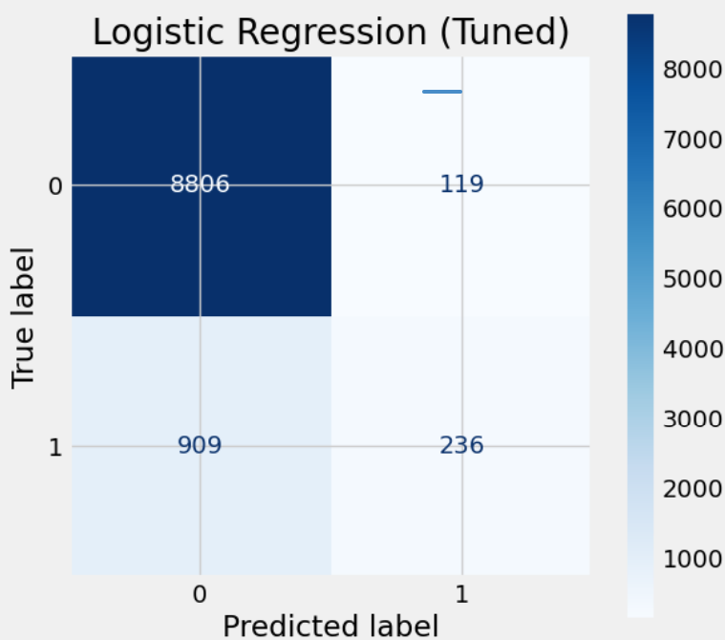 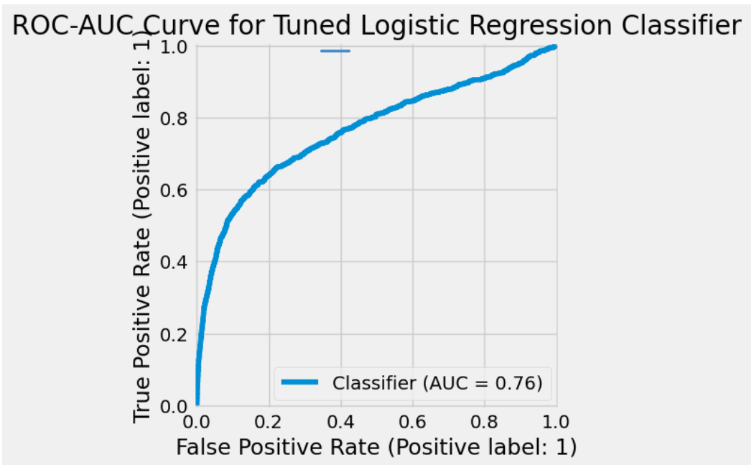

**Interpretation**

1. **High Accuracy, Low Recall**
   * The model is strong at classifying the majority class (negatives) correctly, yielding nearly **90% accuracy**.
   * However, it catches only **~21%** of actual positives.
2. **Moderate Precision**
   * At **~66.5%**, the model’s positive predictions are correct about two-thirds of the time.
3. **Trade-off Reflected in F1**
   * **F1 ~0.314** is modest because of the low recall.
4. **ROC-AUC = 0.76**
   * This suggests the underlying probability estimates are somewhat effective at ranking positives above negatives. Fine-tuning or rebalancing the classes could further improve results.

### Logistic Regression fine tuned with feature selection

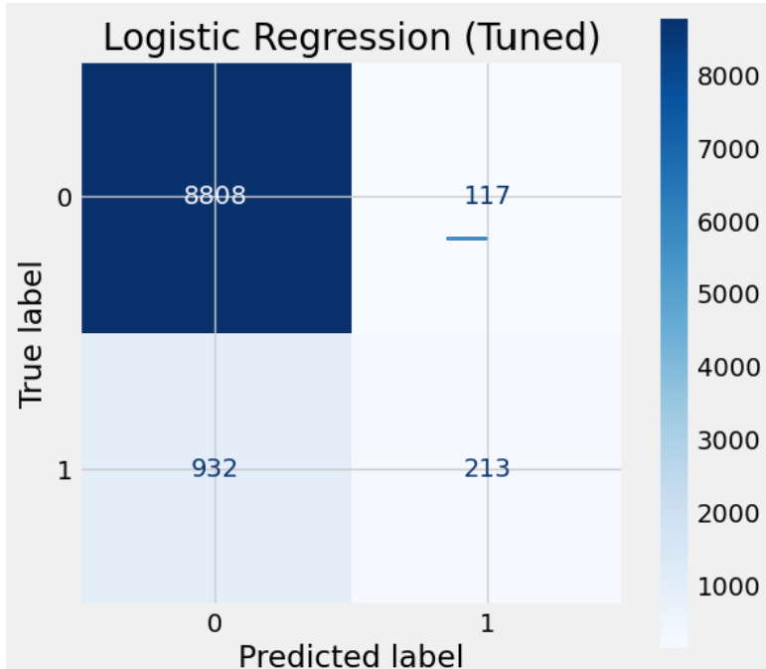 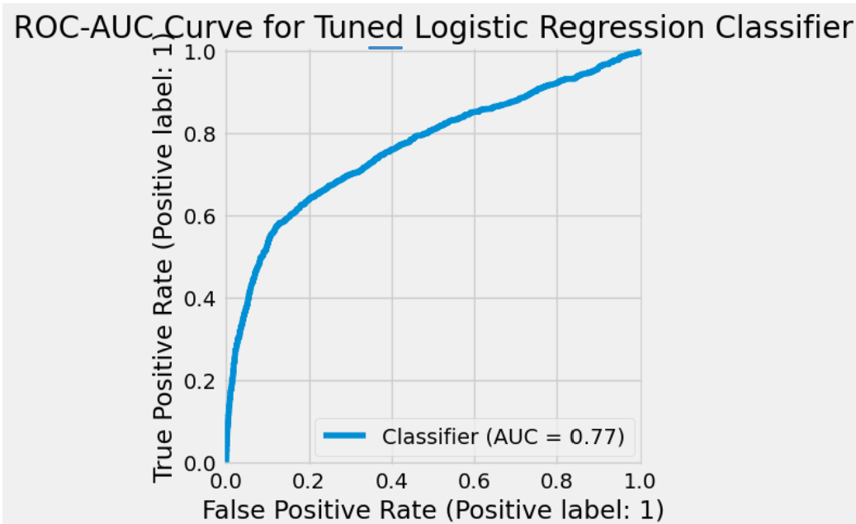

**Interpretation**

1. **High Accuracy, Low Recall**
   * The model is quite good at predicting negatives (high TN), which drives up accuracy to ~89.5%.
   * It struggles to catch positives (recall ~18.6%), which could be problematic if your goal is to identify as many positive cases as possible.
2. **Moderate Precision (~0.645)**
   * Positive predictions are correct around 64.5% of the time.
3. **F1 ~0.289**
   * The low F1 is driven by the imbalance between precision and recall.
4. **ROC-AUC = 0.77**
   * Shows the model’s probability ranking is moderately effective, though it still misses many actual positives at the default threshold of 0.5.

### Logistic Regression fine tuned with feature selection and class_weight=’balanced’

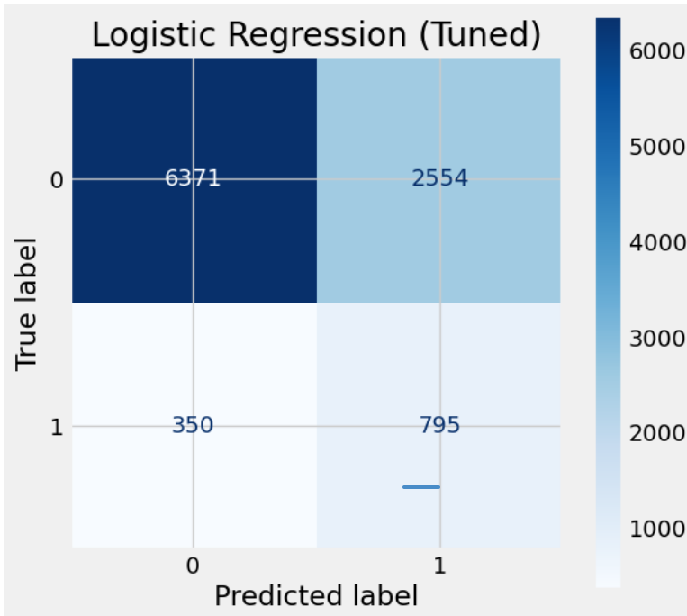 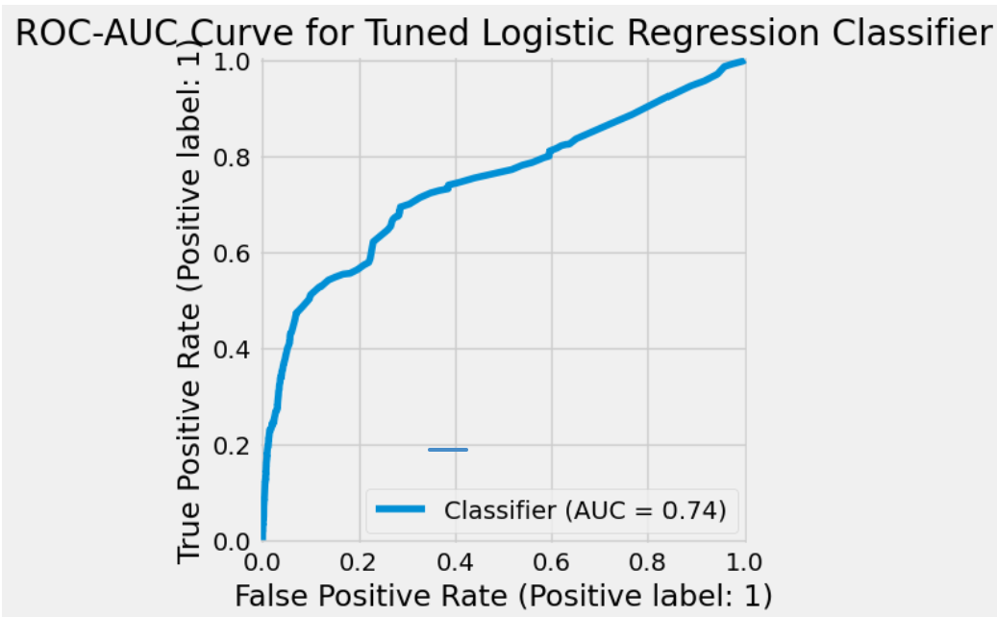

**Interpretation**

1. **High Recall, Low Precision**
   * At ~69.4% recall, the model successfully identifies most positives.
   * Precision is only ~23.7%, meaning many predicted positives are false positives.
2. **Accuracy ~71.2%**
   * Lower than some previous Logistic Regression models that had higher accuracy but much lower recall.
   * This shift typically happens when you apply techniques like class_weight="balanced" or otherwise bias the model to catch more positives.
3. **F1 ~0.353**
   * Moderately low, but still higher than if the recall were extremely low. The big gap between precision and recall pulls F1 down.
4. **ROC-AUC = 0.74**
   * Probability estimates have moderate discriminative power. However, the default threshold emphasizes high recall over precision.

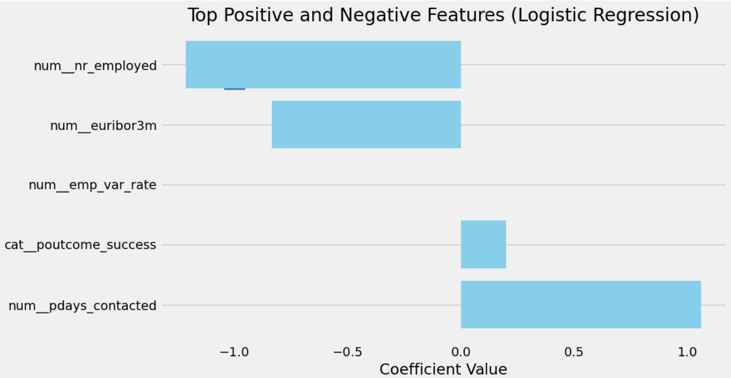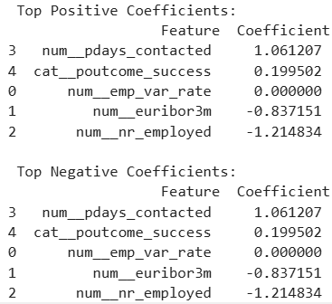

**Top Positive Features**

1. **cat_poutcome_success** (coefficient ≈ +1.06)
   * Indicates that if the outcome of a **previous marketing campaign** was “success,” it strongly **increases** the likelihood of subscribing again.
   * Since it’s a categorical feature, being in this category vs. the baseline (e.g., “nonexistent” or “failure”) adds about +1.06 to the log-odds.
2. **num_euribor3m** (coefficient ≈ +0.85)
   * Refers to the **3-month Euribor interest rate** at the time of contact. A higher Euribor rate is associated with a higher probability of subscription.
   * For each 1-point increase in this rate, the log-odds of subscription go up by ~0.85.
3. **num_emp_var_rate** (coefficient in the positive range)
   * This is often the **employment variation rate**—a measure of economic climate. A positive coefficient suggests that when the employment variation rate is higher, the likelihood of subscription increases.

**Top Negative Features**

1. **num_pdays_contacted** (coefficient ≈ -2.02)
   * Typically represents the **number of days since the client was last contacted** (or possibly how many days a campaign has been running). A large negative coefficient means that **more days** since last contact **strongly reduce** the probability of subscription.
   * Each unit increase lowers the log-odds by ~2.02, which is quite substantial.
2. **num_nr_employed** (coefficient ≈ -1.21)
   * Often represents the **number of employees** (in the economy or in a certain sector) at a given time. A negative sign implies that when this figure is higher, the likelihood of subscription goes down, possibly reflecting economic conditions where people are less inclined to subscribe to new products.

**Using These Insights**

* **Target “Success” Clients**: The large positive coefficient on cat_poutcome_success suggests it’s fruitful to re-contact clients who had a successful outcome in a past campaign.
* **Timely Follow-Ups**: Because num_pdays_contacted is strongly negative, try to minimize the time between contacts (or focus on recently contacted leads).
* **Monitor Economic Factors**: If dataset includes real-time interest rates and employment metrics, you can adapt campaigns during more favorable economic conditions (high emp_var_rate, certain Euribor levels).

### Logistic Regression fine tuned with feature selection and class_weight=’balanced’ (MinMaxScaler)

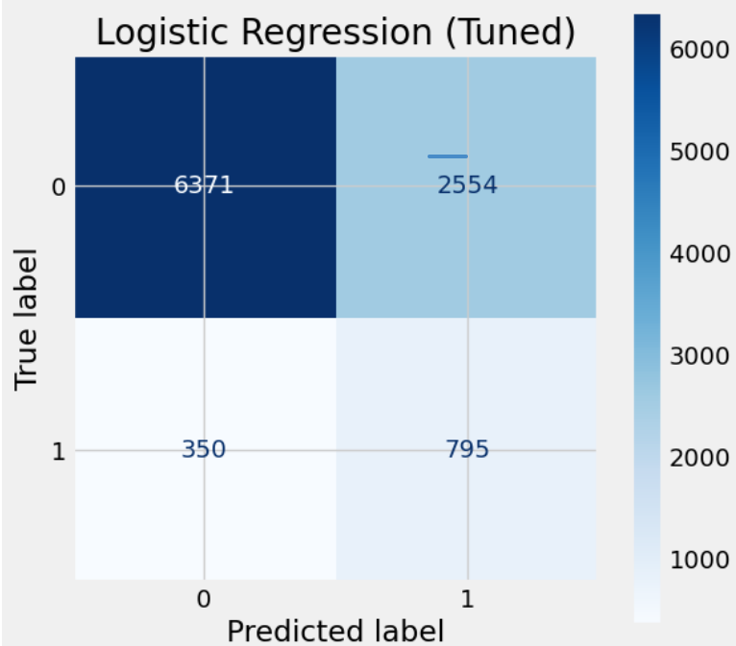 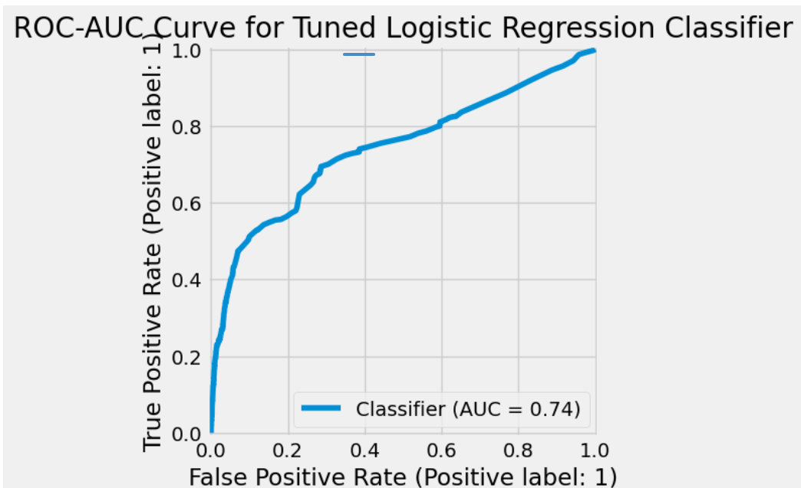

**Interpretation**

1. **High Recall, Low Precision**
   * At ~69.4% recall, the model successfully flags most positive cases.
   * However, precision is only ~23.7%, meaning a large portion of predicted positives are false alarms.
2. **Accuracy ~71.2%**
   * This is lower than some logistic regression models that achieve ~90% accuracy but at the expense of recall.
   * The model is clearly prioritizing recall over precision.
3. **F1 ~0.353**
   * The F1 is moderate, reflecting the trade-off between catching many positives (good recall) and misclassifying many negatives as positives (poor precision).
4. **ROC-AUC = 0.74**
   * Indicates a reasonable (though not exceptional) probability ranking of positives over negatives.

## Decision Tree:

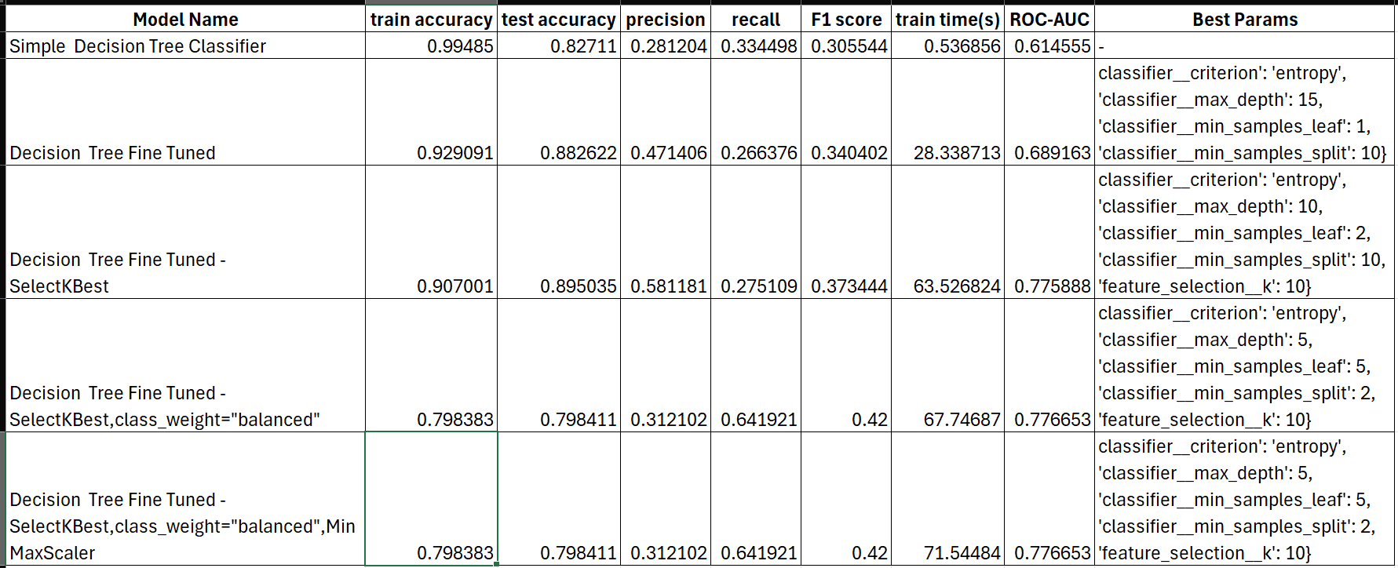

**Key Takeaways**

1. Rows 1–3: Higher Accuracy, Lower Recall
   * The Simple and Fine Tuned models achieve higher test accuracy (up to ~89.5%), but recall is relatively low (~27–33%).
   * Row 3 (Fine Tuned + SelectKBest) stands out for its best test accuracy (0.895), best precision (0.58), and highest ROC-AUC (0.776) among these high-accuracy models.
2. Rows 4–5: Lower Accuracy, Higher Recall
   * Adding class_weight="balanced" and limiting max depth yields a model that catches ~64% of positives, up from ~27%.
   * Accuracy drops to ~79.8%, and precision drops to ~0.31.
   * F1 improves to 0.42, indicating a better balance for applications that prioritize identifying positives.
3. Trade-offs
   * If you need high accuracy or precision, pick Row 3.
   * If you need high recall (and can tolerate lower accuracy), pick Row 4 or 5.
   * Scaling (MinMaxScaler) does not help decision trees (Rows 4 vs. 5 have identical metrics).
4. Training Time
   * Rows 1 (simple) is fastest (~0.54 s) but overfits and performs poorly in recall/precision.
   * Rows 2–5 take significantly longer (28–72 s), but offer better overall metrics depending on your goal.

### Simple Decision Tree

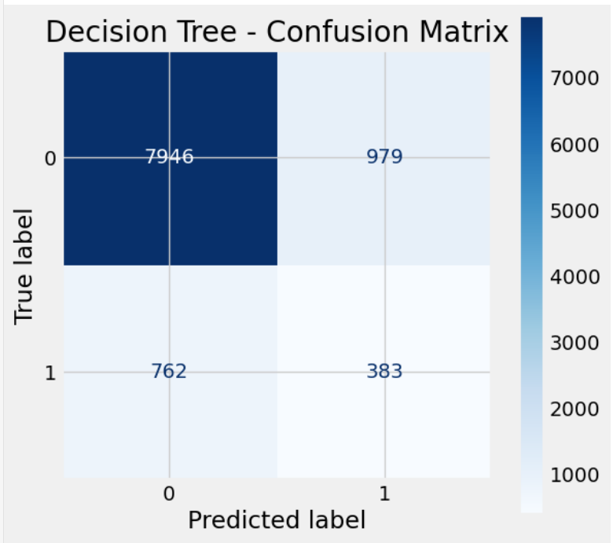 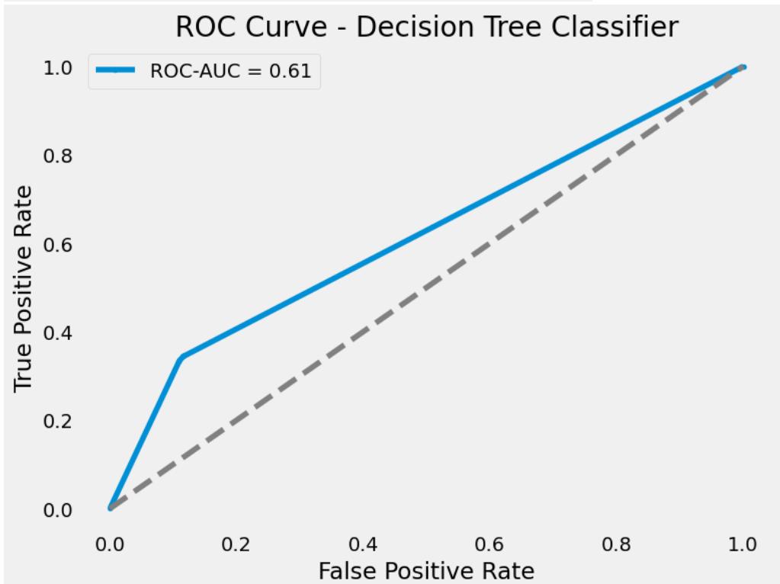

**Interpretation**

1. **High Accuracy, Low Precision & Recall**
   * The model achieves **82.7% accuracy**, primarily by correctly classifying most negatives.
   * However, it struggles on the positive class (precision ~0.28, recall ~0.33).
2. **AUC = 0.61**
   * Indicates a weak ability to rank-order positives above negatives.
3. **Potential Class Imbalance**
   * If the dataset is imbalanced (with many more negatives), high accuracy can be misleading.
   * The model’s low recall suggests it misses most positive cases.

### Decision Tree fine tuned

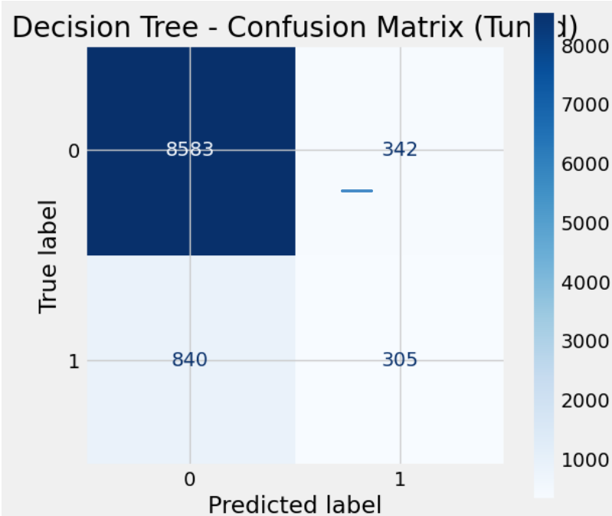 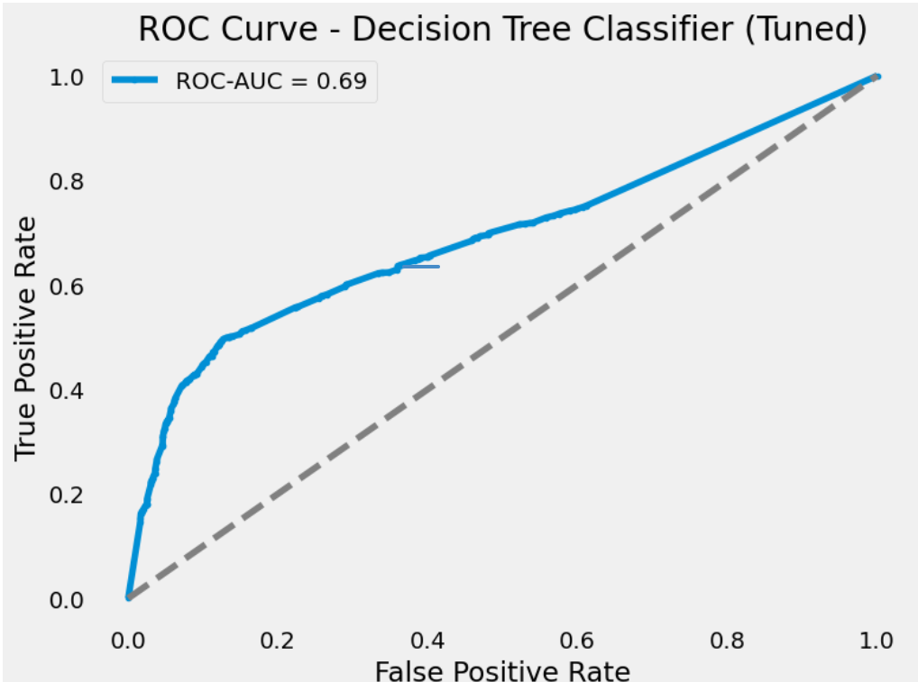

**Interpretation**

1. **High Accuracy, Moderate Precision, Low Recall**
   * Accuracy (~88.2%) is largely driven by correctly identifying the majority class (negatives).
   * Precision (~49.6%) is almost half, but recall is quite low (~28.5%), indicating many missed positives.
2. **F1 ~0.36**
   * Reflects a substantial gap between precision and recall. If your application demands capturing more positive cases, you may want to increase recall.
3. **AUC = 0.69**
   * Shows moderate probability-ranking ability, but the model is not strongly discriminating the minority class at the default threshold of 0.5.

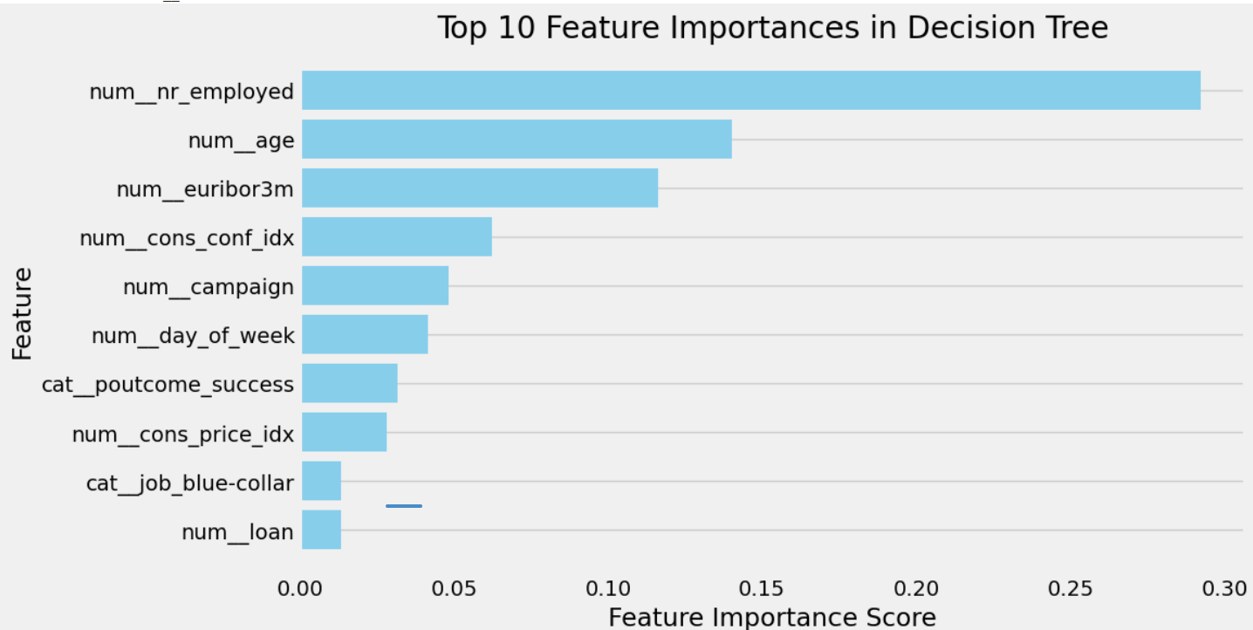

1. **num_nr_employed**
   * Often represents the total number of employees (in thousands) in the economy.
   * A large importance suggests economic conditions (e.g., higher or lower employment) strongly influence whether someone subscribes.
2. **num_age**
   * The customer’s age.
   * Age can correlate with financial stability, risk tolerance, or product needs, making it a strong discriminator.
3. **num_euribor3m**
   * The 3-month Euribor interest rate at the time of contact.
   * Higher or lower interest rates can affect clients’ willingness to invest or subscribe to financial products.
4. **num_cons_conf_idx**
   * The consumer confidence index.
   * Reflects overall economic sentiment; clients are more (or less) likely to subscribe in certain economic climates.
5. **num_campaign**
   * How many times this client has been contacted during the current campaign.
   * Too many contacts might annoy customers (lower chance) or might eventually convert them (higher chance), so it’s a key splitting factor.
6. **num_day_of_week**
   * The day of the week the contact was made (numeric form).
   * Certain days might correlate with better reachability or receptiveness to offers.
7. **cat_poutcome_success**
   * Indicates whether a **previous campaign** with this client ended in success.
   * Clients who previously subscribed are typically more inclined to do so again.
8. **num_cons_price_idx**
   * The consumer price index.
   * Another macroeconomic indicator that can reflect inflation or cost of living, impacting financial decisions.
9. **cat_job_blue-collar**
   * A categorical feature indicating if the client’s job is “blue-collar.”
   * Occupation types can relate to income stability, schedule flexibility, and willingness to subscribe.
10. **num_loan**
    * Indicates if the client has a loan (often 0/1 or the number of active loans).
    * Clients with existing loans might be more cautious or already engaged with financial products.

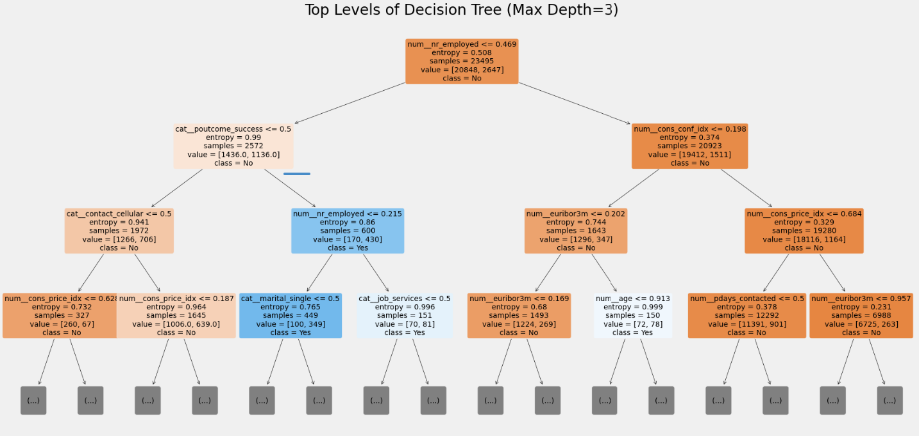

### Decision Tree fine tuned with feature selection

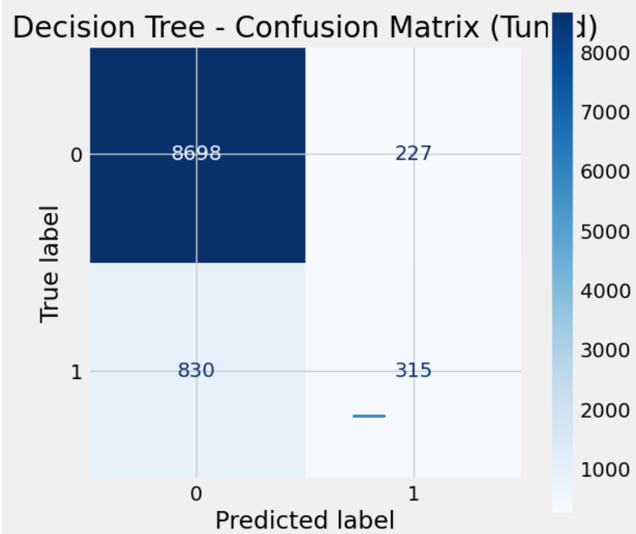 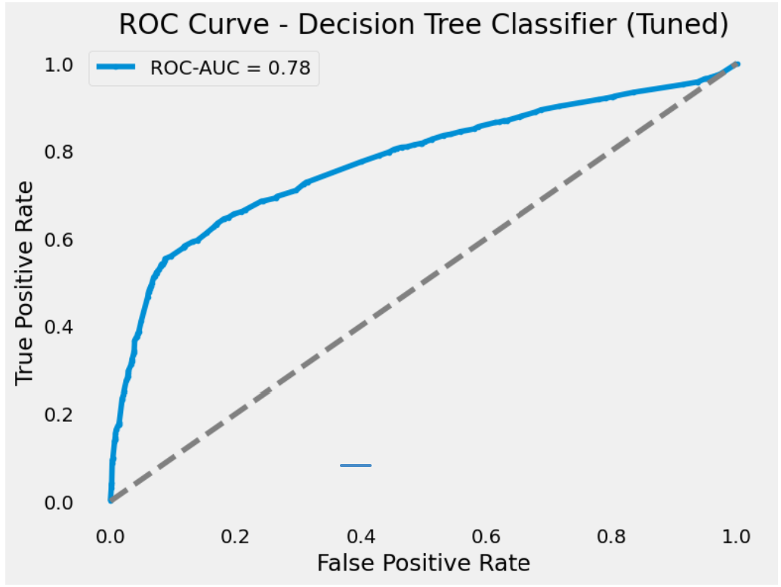

**Interpretation**

1. **High Accuracy, Moderate Precision, Low Recall**
   * Accuracy of **89.5%** largely reflects strong performance on the majority class (true negatives).
   * Precision is moderate (~58%), but recall is only ~27.5%, meaning the model misses most positive cases.
2. **F1 ~0.37**
   * Indicates a limited balance between precision and recall.
3. **ROC-AUC = 0.78**
   * Shows that the model’s probability estimates are reasonably good at separating positives from negatives overall, but the chosen threshold does not favor capturing many positives.

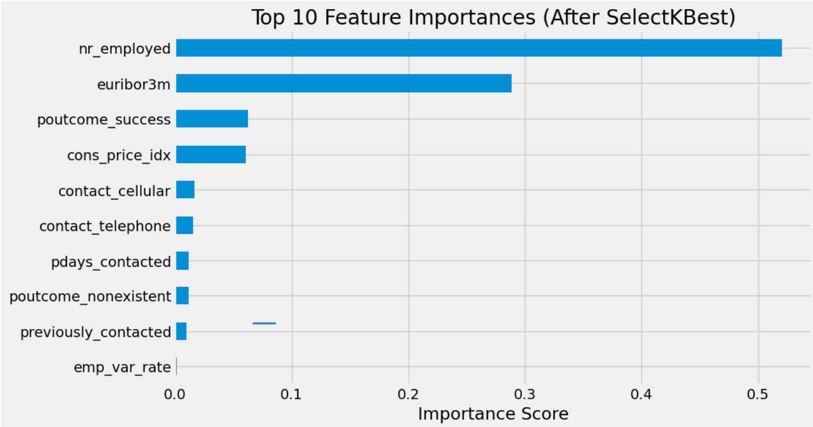

1. **nr_employed**
   * Represents the number of employees (often in the economy). A high importance indicates broader employment figures strongly influence whether a client subscribes.
2. **euribor3m**
   * The 3-month Euribor interest rate. Changes in interest rates can affect customers’ willingness to invest or subscribe to financial products.
3. **poutcome_success**
   * Indicates if the outcome of a **previous marketing campaign** was “success.” Prior success strongly boosts the chance of subscribing again.
4. **cons_price_idx**
   * The consumer price index, reflecting price levels or inflation. Customers may be more or less likely to subscribe depending on economic conditions.
5. **contact_cellular**
   * Whether the contact was made via cellular phone. The contact method can significantly impact response rates.
6. **contact_telephone**
   * Whether the contact was made via a traditional telephone line. Similar to “contact_cellular,” but may appeal to different demographics.
7. **pdays_contacted**
   * Number of days since the last contact. A shorter gap (fewer days) might keep the client more engaged.
8. **poutcome_nonexistent**
   * Indicates no previous campaign outcome was recorded for this client. Lack of prior data can still be informative in how the model splits.
9. **previously_contacted**
   * A binary or numeric feature indicating if (or how many times) the client was previously contacted. Prior contact can shape the client’s receptiveness.
10. **emp_var_rate**
    * The employment variation rate, another economic indicator. It often correlates with consumer confidence and willingness to subscribe.

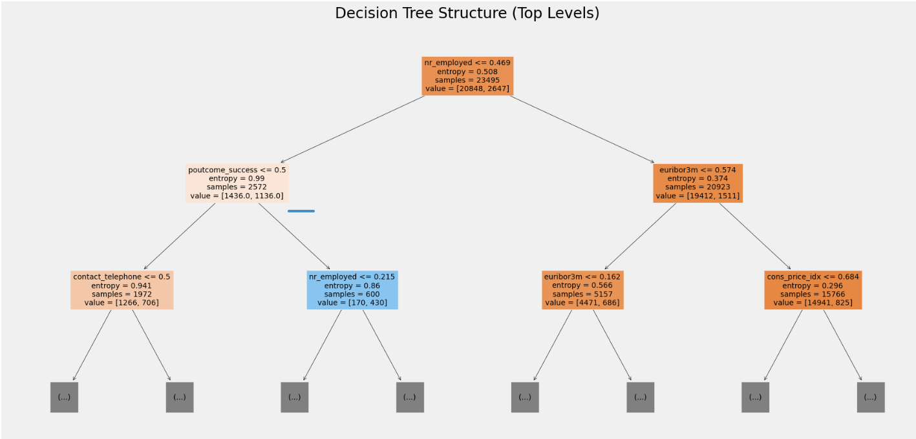

### Decision Tree fine tuned with feature selection and class_weight=’balanced’

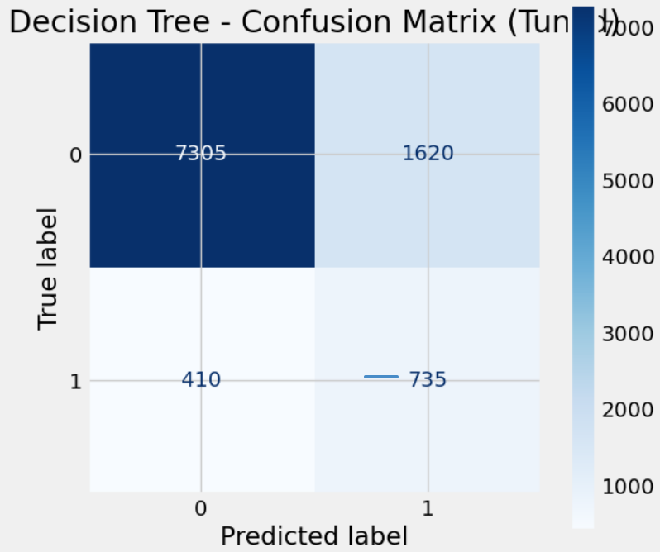 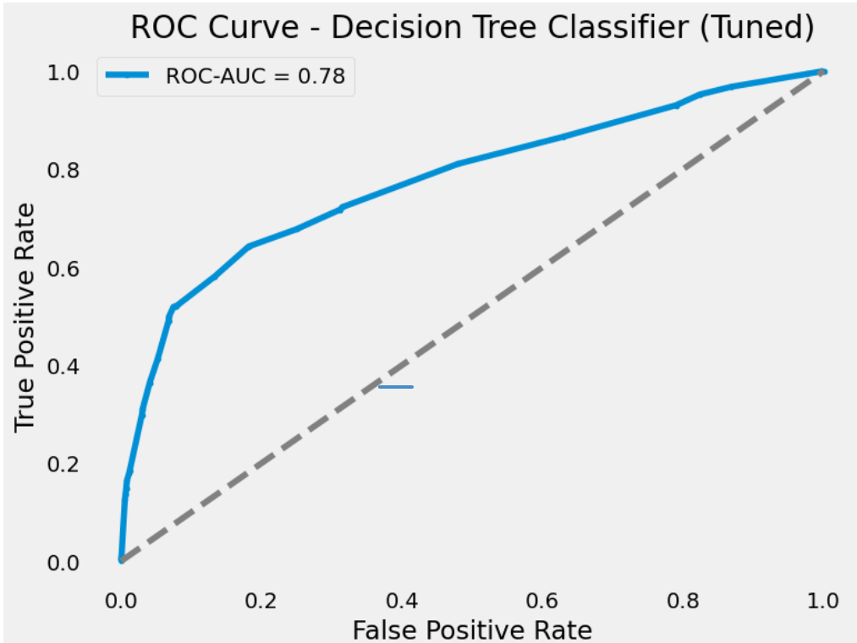

**Interpretation**

1. **Moderate Accuracy (~79.8%)**
   * The model is correct most of the time, largely due to correctly classifying the majority (negative) class.
2. **Balanced Recall (~64.2%) vs. Low Precision (~31.2%)**
   * The model catches a good share of actual positives but also produces many false positives.
3. **F1 ~0.42**
   * The F1 score indicates a middling trade-off between precision and recall.
4. **ROC-AUC = 0.78**
   * Suggests decent probability estimates overall; adjusting the threshold could improve precision or recall, depending on your needs.

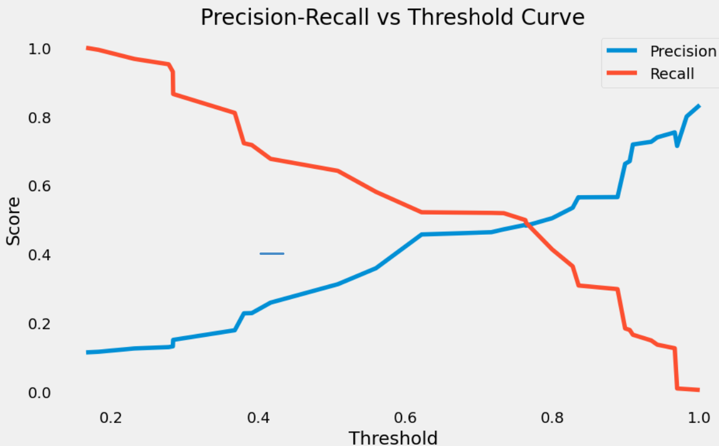

**Typical Behavior**

1. **Low Threshold (< 0.2)**
   * **High Recall:** The model classifies most instances as positive, catching nearly all true positives.
   * **Low Precision:** Many false positives occur because the model is too eager to predict “positive.”
2. **High Threshold (> 0.8)**
   * **High Precision:** The model is very selective about predicting positives, so when it does, it’s usually correct.
   * **Low Recall:** A large fraction of actual positives is missed because the threshold is too strict.
3. **Intermediate Thresholds (~0.4–0.6)**
   * **Trade-off Region:** Precision rises while recall falls, or vice versa. There may be a “sweet spot” where both are balanced in a way that suits your business needs (e.g., maximizing F1 score).

### Decision Tree fine tuned with feature selection and class_weight= ’balanced’ (MinMaxScaler)

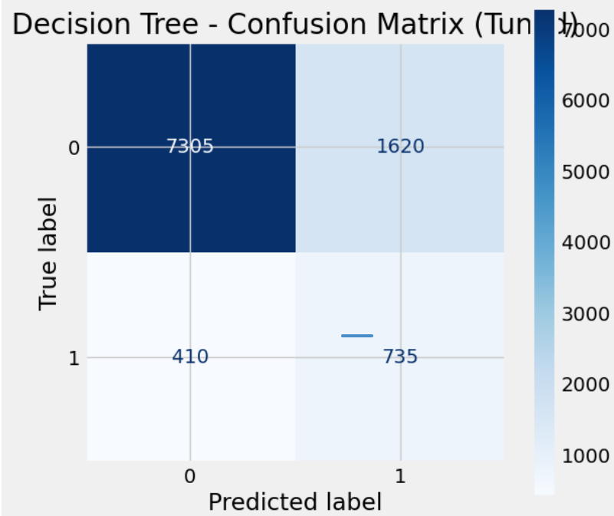 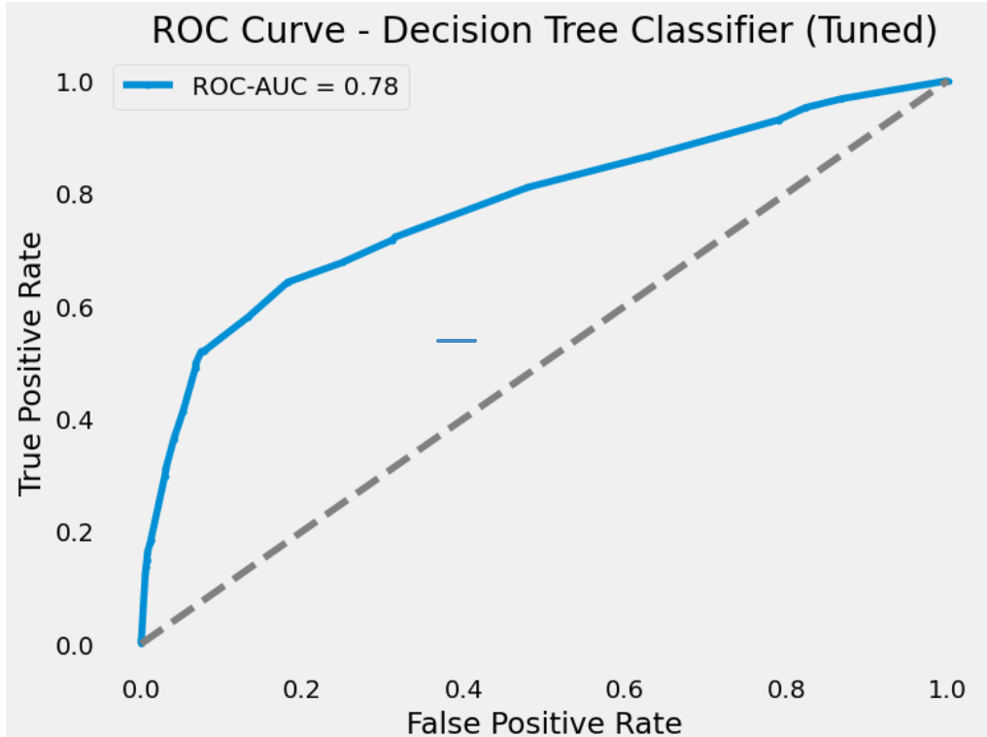

**Interpretation**

1. **High Recall, Low Precision**
   * At the 0.5 threshold, the model captures about 64.2% of positives but has a precision of only 31.2%.
   * This is often acceptable if missing positives is costly (e.g., in medical screening), but it does generate many false positives.
2. **Moderate Accuracy (~79.8%)**
   * Accuracy is decent, but note that if the dataset is imbalanced, accuracy can be misleading.
3. **F1 = 0.42**
   * The moderate F1 score reflects the compromise between recall and precision.
4. **ROC-AUC = 0.78**
   * Suggests the model’s underlying probability estimates are relatively good

## SVM Classifier

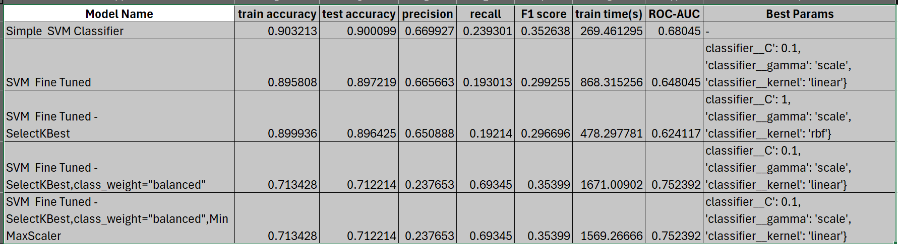

**Key Takeaways**

1. Rows 1–3: High Accuracy, Low Recall
   * They achieve ~89–90% test accuracy but recall is ~19–24%, resulting in F1 ~0.30–0.35.
   * Simple SVM (Row 1) actually outperforms the “fine-tuned” variants on test accuracy, recall, and F1 in this table.
2. Rows 4–5: Lower Accuracy, Higher Recall
   * Adding class_weight="balanced" drastically increases recall (~69.3%) but reduces accuracy (~71.2%) and precision (~0.24).
   * The F1 (~0.35) is comparable to Row 1, but from a different trade-off (high recall vs. high precision).
   * ROC-AUC (~0.75) is the best among all rows, meaning these models rank positives more effectively overall.
3. Choosing a Model
   * If you value overall accuracy (and can afford missing many positives), Row 1 is best.
   * If you need to catch more positives (high recall) or want a higher ROC-AUC for threshold tuning, Rows 4 or 5 are better.
   * Rows 2–3 do not improve on the baseline in terms of test metrics, despite longer training times.
4. Training Time
   * SVMs can be expensive on large datasets, especially with class_weight="balanced" or a non-linear kernel.
   * Row 1 is relatively fast (~269 s). Rows 4–5 can exceed 1500+ seconds.

### Simple SVM model

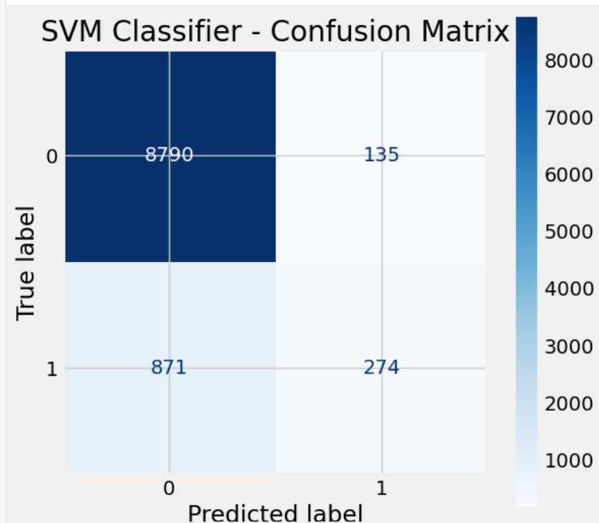 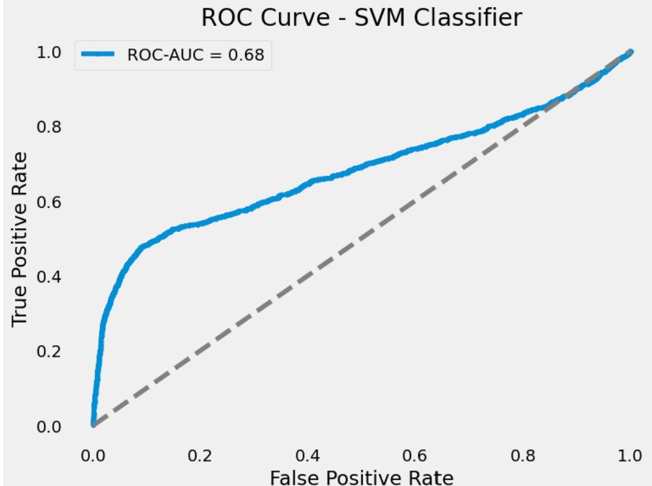

**Interpretation**

1. **High Accuracy, Low Recall**
   * The model is quite good at identifying negatives (TN = 8790) but misses the majority of positives (FN = 871).
   * As a result, the recall is only ~24%, which may be problematic if your goal is to catch most positives.
2. **Precision ~67%**
   * When the model does predict positive, it’s correct about two-thirds of the time.
3. **F1 ~0.35**
   * Reflects the imbalance between moderate precision and low recall.
4. **ROC-AUC = 0.68**
   * Suggests moderate overall discrimination; threshold tuning or class imbalance methods could improve recall at the expense of precision.

### SVM model fine tuned

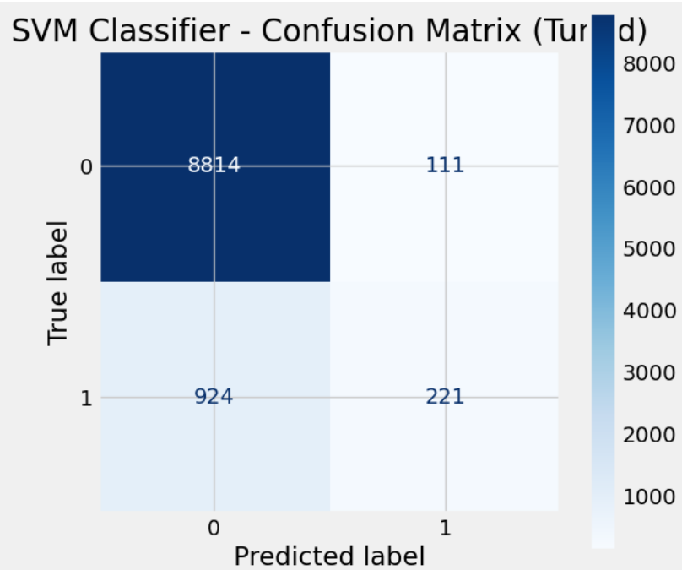 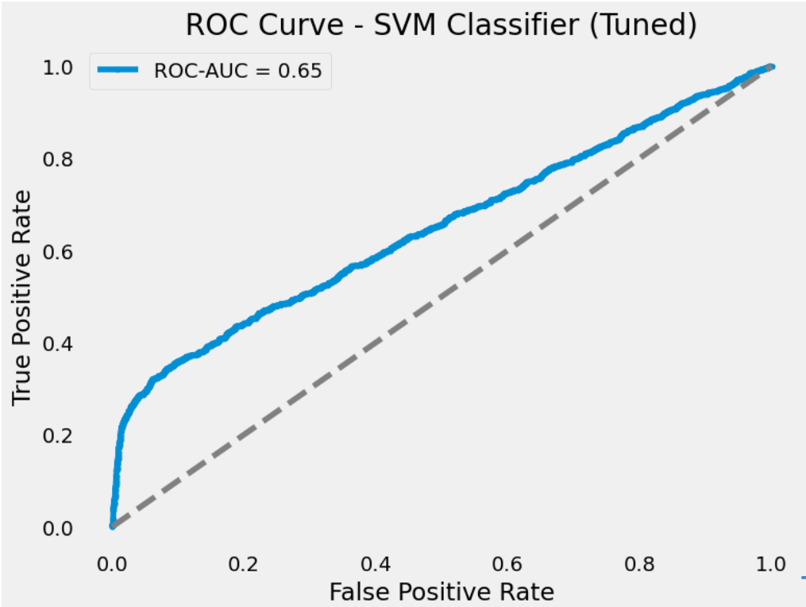

**Interpretation**

1. **High Accuracy, Low Recall**
   * At ~89.7% accuracy, the model handles the majority (negative) class well.
   * However, it catches fewer than 20% of the positives, which could be problematic if your goal is to identify as many positives as possible.
2. **Precision ~66.5%**
   * When the model does predict a positive, it’s correct about two-thirds of the time.
3. **F1 ~0.30**
   * Reflects a significant trade-off between fairly good precision and very low recall.
4. **ROC-AUC = 0.65**
   * The model’s probability estimates offer moderate discrimination. If you need higher recall or a better rank ordering, consider threshold tuning or class imbalance techniques.

### SVM model fine tuned with feature selection

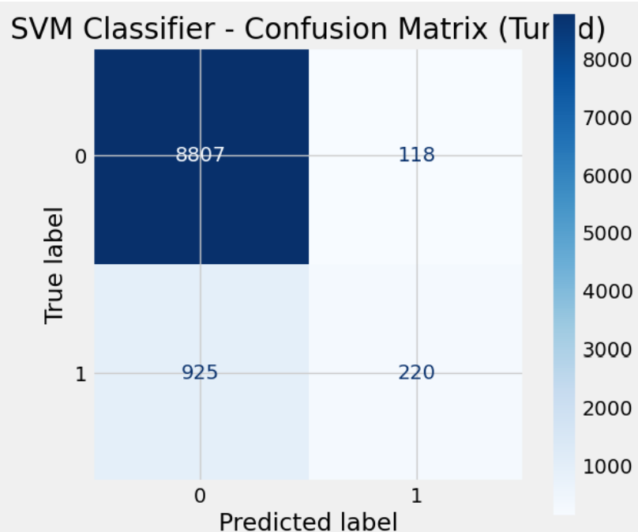 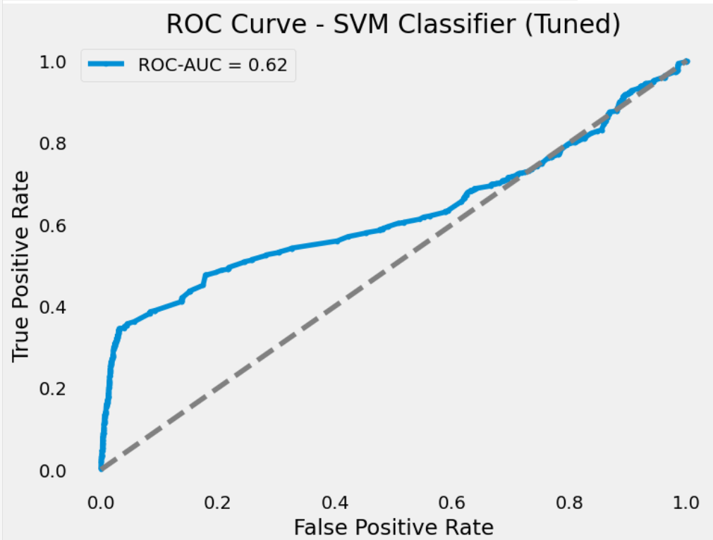

**Interpretation**

1. **High Accuracy, Low Recall**
   * The model achieves **~89.7% accuracy**, largely by correctly classifying the majority (negative) class.
   * However, it misses most positives (recall ~19.2%), which may be problematic if catching positives is important.
2. **Precision ~65%**
   * Positive predictions are correct about two-thirds of the time, but many positives go undetected.
3. **F1 ~0.30**
   * Reflects the imbalance between precision and recall.
4. **ROC-AUC = 0.62**
   * Indicates moderate discrimination power; threshold tuning or handling class imbalance might boost recall.

### SVM model fine tuned with feature selection and class_weight= ’balanced’

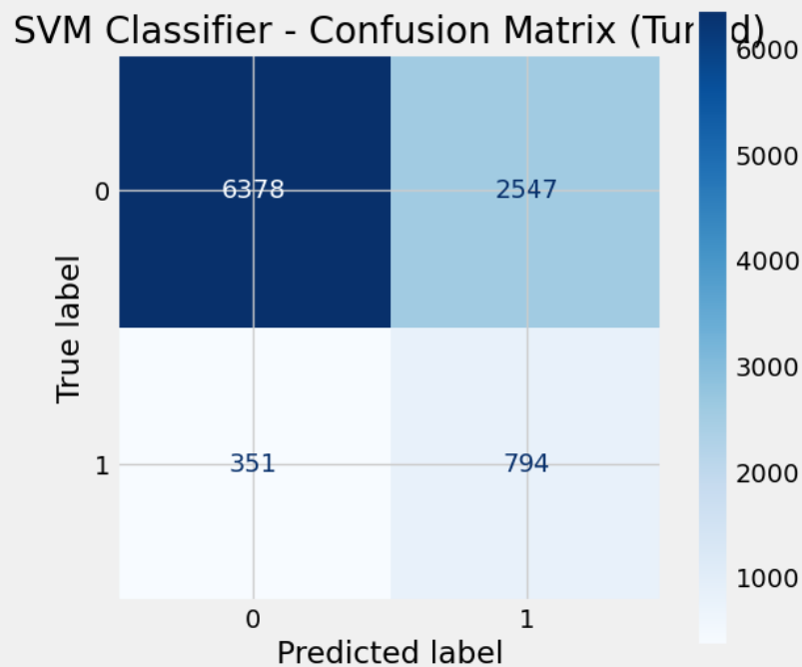 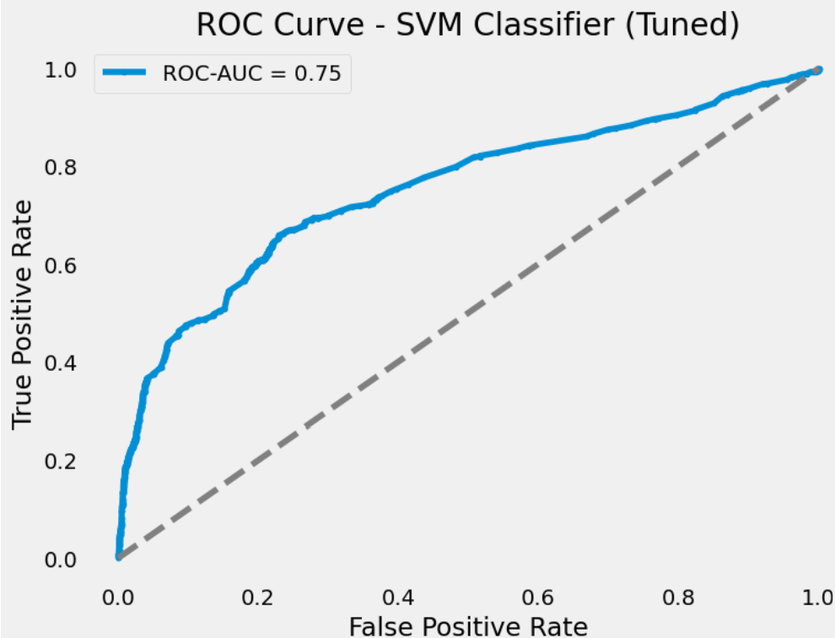

**Interpretation**

1. **High Recall, Low Precision**
   * At the 0.5 threshold, the model captures ~69% of actual positives, which is good if missing positives is costly (e.g., medical screenings, fraud detection).
   * However, only ~24% of predicted positives are correct, leading to many false alarms.
2. **Accuracy ~71.2%**
   * Lower than some other SVM models that might achieve higher accuracy but far lower recall.
3. **F1 ~0.355**
   * Reflects a compromise: decent coverage of positives but many false positives.
4. **ROC-AUC = 0.75**
   * Indicates the underlying probability estimates have moderate to good discriminative power. Adjusting the threshold could yield different precision–recall trade-offs.

### SVM model fine tuned with feature selection and class_weight= ’balanced’ (MinMaxScaler)

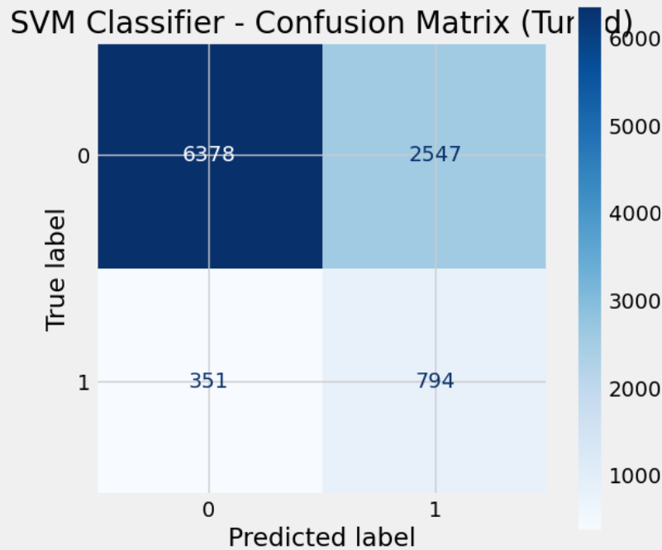 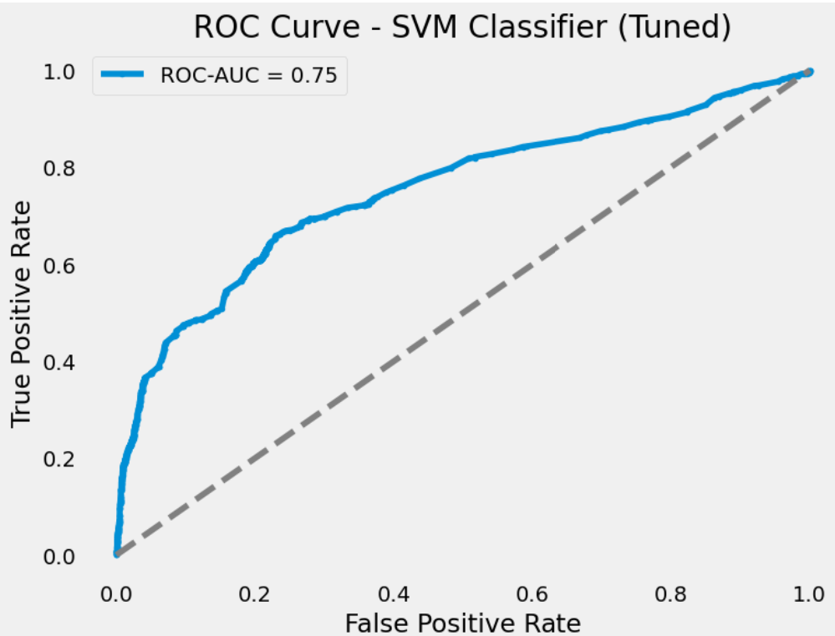

**Interpretation**

1. **High Recall (~69%)**: The model catches most positive cases, useful when missing positives is costly (e.g., medical or fraud detection).
2. **Low Precision (~24%)**: Many predicted positives are false alarms, which may be acceptable if you can handle extra follow-up.
3. **Moderate Accuracy (~71%)**: The model sacrifices some accuracy to achieve higher recall.
4. **F1 = 0.355**: Reflects the trade-off—recall is strong, but precision is weak.

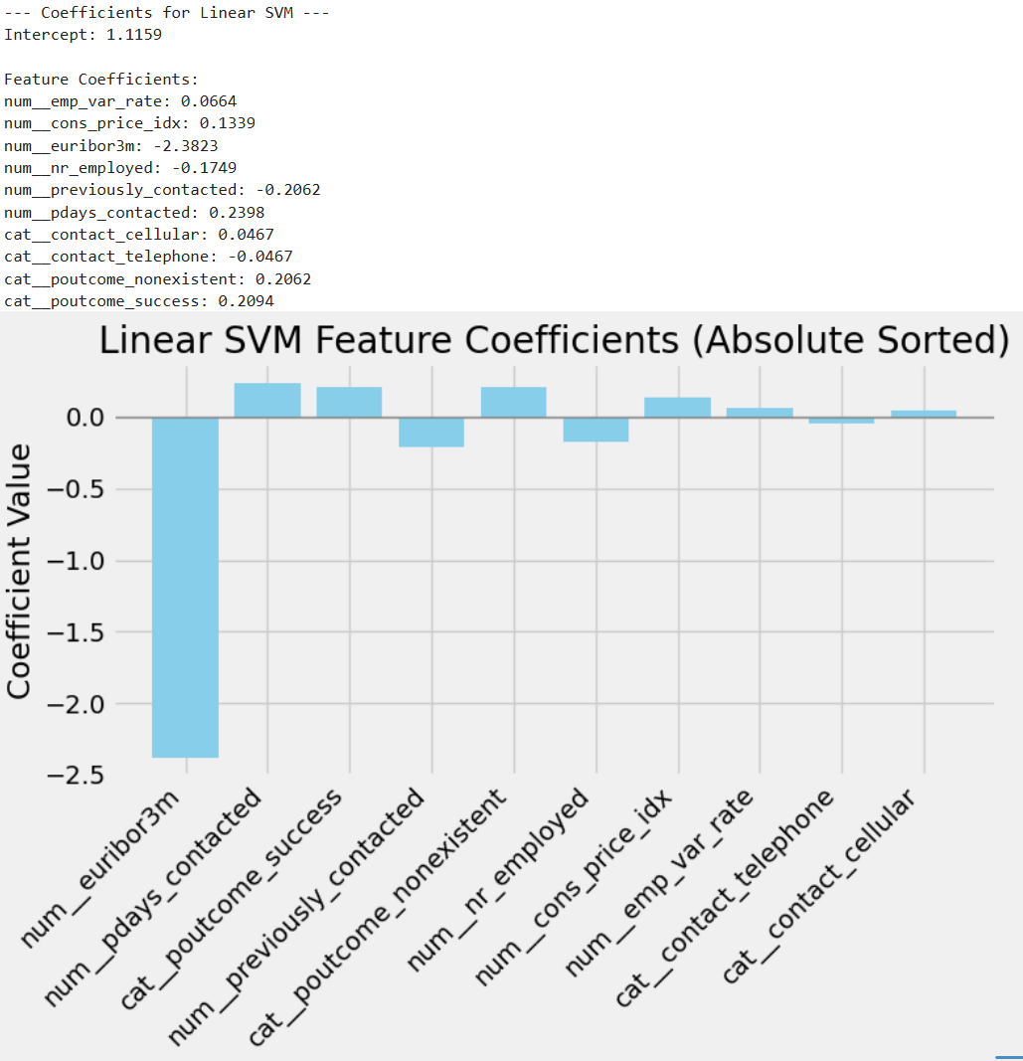

* **Large positive coefficients** (e.g., cat_poutcome_success, num_pdays_contacted) **strongly increase** the decision function, making a positive classification more likely.
* **Large negative coefficients** (e.g., num_euribor3m) **strongly decrease** the decision function, favoring a negative classification.
* Smaller coefficients (like cat_contact_telephone) have a weaker influence.
* The **intercept** (1.1159) shifts the entire decision boundary toward predicting “positive,” and each feature’s coefficient then nudges that boundary up or down.

# Model comparison

|  |  |  |  |  |  |  |
| --- | --- | --- | --- | --- | --- | --- |
| **Model** | **Test Accuracy** | **Precision** | **Recall** | **F1 Score** | **ROC-AUC** | **Train Time (s)** |
| **KNN** | 0.6765 | 0.2118 | 0.6777 | 0.3227 | 0.7269 | 0.2292 |
| **LogisticRegression** | 0.7116 | 0.2374 | **0.6943** | 0.3538 | 0.7421 | 0.2795 |
| **DecisionTree** | 0.7984 | 0.3121 | 0.6419 | **0.42** | **0.7767** | **0.1468** |
| **SVM** | 0.7122 | 0.2377 | 0.6935 | 0.354 | 0.7524 | 192.6366 |

**Key Observations**

1. **Highest Recall**
   * **Logistic Regression** (0.6943) and **SVM** (0.6935) both catch around 69% of positives, which is higher than KNN (0.6777) or Decision Tree (0.6419).
   * If **not missing potential subscribers** is your top priority (i.e., **max recall**), then **Logistic Regression** edges out slightly at 0.6943 vs. SVM’s 0.6935.
2. **Highest F1 Score**
   * **Decision Tree** achieves the best F1 (0.4200) and also the highest ROC-AUC (0.7767).
   * However, its recall is 0.6419, which is lower than Logistic Regression or SVM.
3. **Training Time**
   * **Logistic Regression** is much faster (~0.28 s) than SVM (~192.64 s) and still achieves effectively the same recall.
   * **Decision Tree** is fastest overall (0.15 s) but with a lower recall than LR/SVM.
4. **Precision**
   * All models have modest precision (~0.21–0.31 for KNN/DT, ~0.24 for LR/SVM), which is typical when recall is emphasized.

**Which Model Works Best Here?**

Given the **business objective** is to **avoid missing potential subscribers** (i.e., prioritize **high recall**), **Logistic Regression** offers:

* **Highest recall** (0.6943),
* A **short training time** (0.28 s), and
* A **competitive F1** (0.3538).

**SVM** is almost tied on recall (0.6935) and F1 (0.3540), but it takes much longer to train (~192.64 s). If you value speed and only need to slightly edge out SVM in recall, **Logistic Regression** is the best choice.

For more **balanced** approach (higher F1 and ROC-AUC), **Decision Tree** might be appealing (F1=0.42, AUC=0.7767), but its recall is lower (0.6419), meaning more missed positives.

**Bottom Line**

* **Maximizing Recall** → **Logistic Regression** (class_weight="balanced") is best.
* **Balanced Approach** → **Decision Tree** yields higher F1 and ROC-AUC but misses more positives.
* **Nearly Tied with Logistic Regression** → **SVM** has the same recall but is slower to train.

Given the stated goal of **not missing potential subscribers**, **Logistic Regression** is the top recommendation.

# Model comparison with undersampling

|  |  |  |  |  |  |  |
| --- | --- | --- | --- | --- | --- | --- |
| **Model** | **Test Accuracy** | **Precision** | **Recall** | **F1 Score** | **ROC-AUC** | **Train Time (s)** |
| **KNN** | 0.8406 | 0.372 | 0.582 | 0.454 | 0.7395 | 20.3 |
| **LogisticRegression** | 0.7116 | 0.237 | **0.694** | 0.354 | 0.7415 | **4.56** |
| **DecisionTree** | 0.7949 | 0.311 | 0.661 | **0.423** | **0.7781** | 9.59 |
| **SVM** | 0.7116 | 0.237 | **0.694** | 0.354 | 0.7424 | 170.99 |

**Key Observations**

1. **Highest Recall**
   * **Logistic Regression** and **SVM** both achieve **recall ≈ 0.694**, which is higher than KNN (0.582) or Decision Tree (0.661).
   * If **minimizing missed positives** (false negatives) is your main goal, **Logistic Regression** or **SVM** are the top contenders.
2. **F1 Score**
   * **Decision Tree** has the highest F1 (~0.423), indicating a more balanced trade-off between precision and recall—but with a slightly lower recall (0.661).
3. **Precision**
   * All models have modest precision (~0.24–0.37) because undersampling and emphasis on recall typically lower precision.
4. **ROC-AUC**
   * **Decision Tree** leads with **0.7781**, suggesting strong probability discrimination overall.
   * SVM is second at **0.7424**, closely followed by Logistic Regression (0.7415).
5. **Train Time**
   * **Logistic Regression** is the fastest (4.56 s) among the high-recall models.
   * **SVM** is significantly slower (170.99 s) but has nearly identical recall and a slightly higher ROC-AUC.

**Which Model Works Best?**

* **If your priority is strictly highest recall** (to avoid missing potential subscribers), **Logistic Regression** and **SVM** are tied at ~0.694.
* **If you also want a relatively quick and interpretable solution**, **Logistic Regression** is best (4.56 s vs. SVM’s 170.99 s).
* **If you want a more balanced model** (higher F1 and the best ROC-AUC), **Decision Tree** could be appealing, but it sacrifices some recall (0.661).
* **KNN** has the best test accuracy (0.8406) but a lower recall (0.582), so it may miss more positives.

Given the **business objective** of not missing potential subscribers (i.e., maximizing recall) and the relatively low cost of contacting extra clients, **Logistic Regression** (or **SVM**) is the top choice. Because they share the same recall, **Logistic Regression** stands out due to **faster training time** and easier interpretability.

# Summary of model comparison

**1. Before Undersampling**

|  |  |  |  |  |  |  |
| --- | --- | --- | --- | --- | --- | --- |
| **Model** | **Test Accuracy** | **Precision** | **Recall** | **F1** | **ROC-AUC** | **Train Time (s)** |
| **KNN** | 0.6765 | 0.2118 | 0.678 | 0.323 | 0.7269 | 0.2292 |
| **LogisticRegression** | 0.7116 | 0.2374 | **0.694** | 0.354 | 0.7421 | 0.2795 |
| **DecisionTree** | 0.7984 | 0.3121 | 0.642 | **0.42** | 0.7767 | **0.1468** |
| **SVM** | 0.7122 | 0.2377 | 0.694 | 0.354 | 0.7524 | 192.6366 |

**Observations (Before Undersampling)**

1. **Highest Recall**: Logistic Regression (0.6943) and SVM (0.6935) → Good for catching positives but with modest precision (~0.24).
2. **Highest F1**: Decision Tree (0.42), plus best ROC-AUC (0.7767) and high accuracy (0.7984). However, recall is slightly lower (0.6419).
3. **Training Time**:
   * **Fastest** is Decision Tree (~0.15 s).
   * **Slowest** is SVM (~192.64 s).

If you **prioritize recall** to avoid missing potential subscribers, **Logistic Regression** or **SVM** stands out. If you want a **more balanced** approach (F1), **Decision Tree** is strong. **KNN** has the lowest accuracy but decent recall (~0.678).

1. **After Undersampling**

|  |  |  |  |  |  |  |
| --- | --- | --- | --- | --- | --- | --- |
| **Model** | **Test Accuracy** | **Precision** | **Recall** | **F1** | **ROC-AUC** | **Train Time (s)** |
| **KNN** | **0.8406** | 0.372 | 0.582 | 0.454 | 0.7395 | 20.3 |
| **LogisticRegression** | 0.7116 | 0.237 | **0.694** | 0.354 | 0.7415 | **4.56** |
| **DecisionTree** | 0.7949 | 0.311 | 0.661 | **0.423** | 0.7781 | 9.59 |
| **SVM** | 0.7116 | 0.237 | **0.694** | 0.354 | 0.7424 | 170.99 |

**Observations (After Undersampling)**

1. **KNN** jumps to the highest test accuracy (0.8406), but recall is moderate (0.582).
2. **Logistic Regression & SVM** still **tie on recall** (~0.694), just like before, with moderate precision.
3. **Decision Tree** has the best F1 (0.423) and highest ROC-AUC (0.7781).
4. **Training Time**: Logistic Regression is still fast (4.56 s), while SVM remains slower (170.99 s).

**Undersampling** often boosts recall for some models at the expense of accuracy or precision. KNN notably improves accuracy here, but its recall (0.582) is lower than Logistic Regression/SVM’s ~0.694. Meanwhile, Decision Tree retains a strong balance (F1=0.423, ROC-AUC=0.7781).

**3. Key Takeaways**

1. **If You Want Highest Recall**:
   * **Logistic Regression** or **SVM** (both ~0.69 recall), either before or after undersampling, is best for minimizing missed positives.
2. **If You Want a More Balanced Approach**:
   * **Decision Tree** often has the best **F1** and strong **ROC-AUC**, though its recall is somewhat lower (~0.64–0.66).
3. **KNN’s Contrasting Results**:
   * **Before** undersampling: Lower accuracy (0.6765) but decent recall (~0.678).
   * **After** undersampling: Best accuracy (0.8406) but recall drops (~0.582).
   * KNN is sensitive to data distribution changes (like undersampling).
4. **Undersampling’s Effect**:
   * Often **improves recall** or changes how models handle the minority class.
   * May lower precision or accuracy depending on the model.
   * In this comparison, it boosts KNN’s accuracy significantly but doesn’t necessarily increase recall for all models.

**Summary**

* **Decision Tree** offers a strong **F1** and **ROC-AUC** if you want a more balanced solution.
* **Logistic Regression** and **SVM** remain the top choices for **max recall**—ideal if you don’t want to miss potential positive cases (e.g., subscribers).
* **KNN** is more sensitive to sampling changes, showing high accuracy after undersampling but lower recall, which might not be optimal if your priority is to catch positives.

# Key Business Findings

1. **Prior Contact Increases Subscription Rates**
   * **What We Saw:** Clients who were contacted before are far more likely to say “yes” than those contacted for the first time.
   * **Why It Matters:** Building on existing relationships often yields better results than cold calls.
2. **Macro-Economic Factors Influence Decisions**
   * **What We Saw:** Variables like interest rates (Euribor) and employment rates affect whether clients sign up.
   * **Why It Matters:** Launching campaigns during favorable economic periods can improve success rates.
3. **Different Models Yield Different Strengths**
   * **Logistic Regression (Balanced)** consistently catches more potential subscribers (**high recall**).
   * **Decision Tree** offers a more balanced overall performance (higher F1) but misses more potential subscribers.
   * **SVM** is similar to Logistic Regression in recall but slower to train.
   * **KNN** can achieve good accuracy but may miss too many potential subscribers.
4. **Class Imbalance Distorts Accuracy**
   * **What We Saw:** If we always predict “no subscription,” we get high accuracy (~88–90%) but miss all actual positives.
   * **Why It Matters:** We must focus on **recall** (catching real subscribers) to avoid losing potential sales.

# Next Steps and Recommendations:

1. **Prioritize Clients with Past Engagement**
   * **Recommendation:** Make follow-up calls or personalized offers to clients who have interacted with the bank before.
   * **Benefit:** They are 2–3 times more likely to subscribe than first-time contacts.
2. **Choose the Right Model**
   * **Recommendation:** Use **Logistic Regression with Balanced Settings** for highest recall (~69%), ensuring fewer missed subscribers.
   * **Benefit:** Minimizes lost opportunities, trains quickly, and is straightforward to interpret.
3. **Leverage Economic Context**
   * **Recommendation:** Track economic indicators (e.g., Euribor rates). If rates are favorable, invest more in campaigns; if not, adjust your approach.
   * **Benefit:** Aligning marketing efforts with good economic conditions can boost subscription rates.
4. **Adjust the Calling Threshold**
   * **Recommendation:** Consider lowering the model’s decision cutoff to flag more potential “yes” clients.
   * **Benefit:** Increases the number of possible subscribers contacted, especially important if phone call costs are low.
5. **Monitor and Refine Regularly**
   * **Recommendation:** Retrain or tune the model every few months, as client behavior and economic conditions change.
   * **Benefit:** Ensures predictions stay accurate over time, maintaining high conversion rates.